AGRICULTURE FORM FOUR

**NEW SYLLABUS BASED NOTES**

**VOLUME 4**

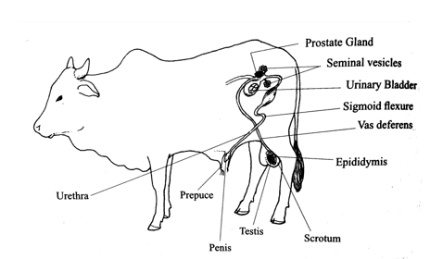

**COMPILED BY**

**PHILLIP MLOWOKA GUDULU CHIRWA**

(**TARGET PRIVATE SECONDARY SCHOOL-MZUZU CITY)**

Passing agriculture at MSCE has never been easy and straight forward. This pamphlet has brought all the resources which are requisite so as to minimize lavishness of precious time probing for valuable information in different books

**ACKNOWLEDGEMENT**

My profound thanks should go my spouse Chimwemwe Chakwira who persistently encouraged me to work as if there is no tomorrow so that this pamphlet should be finalized despite the myriads of predicaments l encountered. I would be doing unfairness if I do not recognize the omnipresent **GOD** for the free endowment of life.

Special dedication to my children **madalitso (daughter) and Emmanuel chirwa** (son)

© **PHILLIP CHIRWA 2022**

All rights reserved. No part of this pamphlet may be reproduced, stored in retrieval system or transmitted in any form or by any means, electronic, mechanical, photocopying, recording or otherwise without the prior written permission. Once found the law shall not hesitate to take its course (confiscation as instant step and no discussion here)

Editor : Phillip Chirwa

Proofreader: Johnson chirwa

Designed by: Phillip Mlowoka Gudulu Chirwa

Date :10th January, 2022

TABLE OF CONTENTS

UNIT 1 SOIL DEGRADATION 4

UNIT 2 AGRICULTURE AND CLIMATE CHANGE 7

UNIT 3 LAND DRAINAGE 11

UNIT 4 FARM MECHANIZATION 14

UNIT 5 FARM POWER 20

UNIT 6 GENDER AND AGRICULTURAL TECHNOLOGY 23

UNIT 7 IMPROVED FARMING TECHNOLOGY 24

UNIT 8 AGRICULTURAL MARKETING AND TRADING 26

UNIT 9 PRICE ELASTICITY OF SUPPLY AND DEMAND 33

UNIT 10 CROP IMPROVEMENT 39

UNIT 11 MANGO PRODUCTION 42

UNIT 12 CROP PROCESSING 45

UNIT 13 PASTURE 47

UNIT 14 BREED OF CATTLE 59

UNIT 15 REPRODUCTIVE SYSTEMS OF POULTRY AND CATTLE 72

UNIT 16 LIVESTOCK IMPROVEMENT 79

# UNIT 1 SOIL DEGRADATION

* **Soil degradation**: refers to the loss in value and quality of soil.
* This occurs due to soil erosion

**Forms of soil degradation**

* They are three forms

1. Physical
2. Chemical
3. Biological
4. **Physical degradation**

* Occurs when the structure of soil is destroyed by rain or machines.
* The broken particles by machines are then eroded through wind or rain water
* Particles broken by rain become puddle, known as puddle erosion.

**Types of erosion**

1. **Water erosion**

* The main agent of soil erosion in Malawi

**Forms of water erosion**

1. **Splash erosion**

* Occurs due to raindrop impact that displaces soil particles as they hit the ground

1. **Rill erosion**

* Small streams due to surface runoff after rainfall dig small channels called rills on the ground.

1. **Gully erosion**

* If unchecked rill erosions leads into gully erosion where large channels are made on ground
* It is the most serious type

1. **Sheet erosion**

* A large body of shallow water runs down the slope carrying away with it the top soil {only 10% of water erosion is due to surface runoff (rill, gully and sheet erosion}

1. **Wind erosion**

* Strong winds blow away top loose soil particles during the dry season.

1. **Physical erosion**

* Due to soil structure destruction by rain or machines and loose particles eroded by rain water or wind.
* If soil has too much water, it becomes puddle, leading to puddle erosion.

1. **Chemical degradation**

* Due to excessive use of;

1. **Fertilizer**

* Sulphate of ammonia makes soil acidic and toxic to some crops e.g. maize

1. **Pesticides**

* Mostly in common cotton growing areas since cotton demands mores pesticides.

1. **Biological degradation**

* Soil is trampled by people and animals and carried by wind or water
* Earthworms and termites are beneficial but also destroy soil structure making it susceptible to erosion(through the tunnels which are made in the soil).

**Causes of soil degradation**

1. **Soil erosion:** loss of fertile top soil. It is a natural phenomenal but it is induced by human activities.
2. **Salinization:** this is the accumulation of soluble salts in the soil. There are two types soil salinity.
3. **Dry land salinity**

* Common in low rainfall areas where rate of infiltration is lower than the rate of evapotranspiration, hence there is no adequate water to wash down the soluble salts

1. **Irrigation induced salinity**

* Occurs when the soil receives more water by irrigation than the dispersal ability by underground aquifers and drainage system. This makes the water table with dissolved salts to rise up to the roots zones of the crops.

1. **Soil acidification:** this is the gradualalteration of the degree of the acidity or alkalinity in the soil solution. It can be brought about by continuous use of acidifying fertilizers such as sulphate of ammonia
2. **Leaching:** this is the washing down of nutrients to deeper horizons. It is facilitated by excess water in the either from irrigation or rain.
3. **Soil compaction:** this is the physical consolidation of the soil by an applied mechanical force. This destroys soil structure which interferes with various physical characteristics of the soil.
4. **Human activities such as**

* Deforestation and clearing of vegetation leaves land bare
* Burning of crop remains kills soil organisms, which is responsible for decompositions of soil organics matter and improve soil fertility
* Poor cultivation methods such as making ridges along the steep slope and river banks which increases soil erosion
* Overgrazing reduces vegetation cover and soil are loosely held due to absence of vegetation roots, they can easily be blown away

**Cause-effects problem tree on soil degradation**

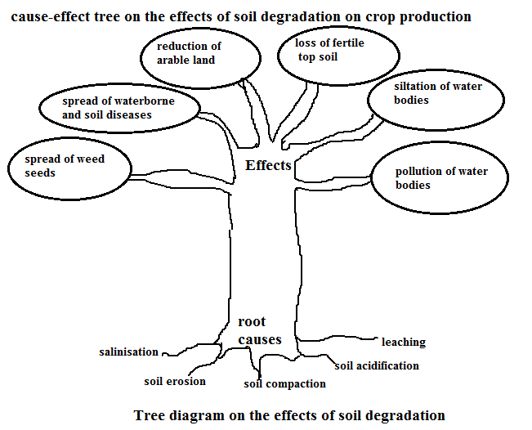

**Effects of soil degradation on crop production**

* Loss of fertile top soil hence low yields
* Reduction of arable land due to formation of gullies
* Spread of water-borne and soil borne diseases which are carried by flooded and when human drinks such water may contract diseases
* Spread of weeds seeds. As running from one place to another, it may carry and spread weeds seeds to the new area.
* Siltation of water bodies’ due to deposition of soil into water bodies hence reduces in water resources.
* Flooding Floods water may result into damage of crops in fields and destruction of farm structures.
* Pollution of water resources. This is because of chemicals surface that are carried from upland are deposited in water resources and they become polluted destroying aquatic life.

**The relationship between rapid population growth and soil degradation**

* Human population has been increasing at an alarming rate in the whole world and Malawi is not an exceptional. High population of Malawi has adverse effects on soil degradation.

**Population growth causes soil degradation in the following ways**

* The need for more food to cater for the growing population as a result more perennial vegetation are replaced with annual crops which are not good in combating soil degradation
* Demand for fuel woods as a result more trees are cut down leaving bare land which is less productive and also exposing land to soil erosion agents.
* Need for shelter and furniture, a result more trees are cut down leaving bare land which is less productive
* Demand for fiber such as cotton and sisal as a more land is cleared hence exposing it to agent erosion. And also humans encroaching into arid and semi-arid areas which do not have stable ecosystem.
* Demand for meat increases as more animals are kept on small piece of land, hence , overstocking leading to overgrazing and soils erosion

**Ways of controlling soil degradation**

* Two main control measures are available.

1. **Biological or cultural control and these include the following;**

* **Planting trees and grasses** which reduces the speed water of runoff
* Planting close growing crops e.g. groundnuts, sweet potatoes, spreading beans, cucumbers which provide maximum soil protection and encourages higher infiltration and minimum runoff.
* **Practicing strip cropping.** Crops planted in strips along the contour and harvested at different times so that there is a strip of crop left at any time.
* **Mulching**. prevents the soil from splash erosion, sun and strong winds
* **A forestation.** Is the planting of large number of trees in areas where they been cut. This helps to the soil structure by binding soil particles together and they create micro climates for rainfall formation.
* **Conserving grazing areas**. This is done by fencing and practicing rotational grazing.
* **Controlling bush fires by creating fire breaks.**
* **Small family sizes**. This reduces the pressure exerted on land and soil resources.

1. **Physical or structural measures. These include the following;**
2. **Constructing storms water drain,** which diverts water from uplands into natural water ways
3. **Constructing gabion/check dams**. These are built across slopes and gullies. Gabions slow down the speed of runoff water.
4. **Construct contours bands** cross the slope following the contours. They catch water and encourage water to sink into the soil.
5. **Cut-off drains/graded bands**. They are channels that drain water from the farm before it causes damage in the form of erosion.
6. **Terraces.** Terrance decreases the length of slope. It is an embankment or ridge constructed across the slope to control water run-off and minimizes soil erosion.

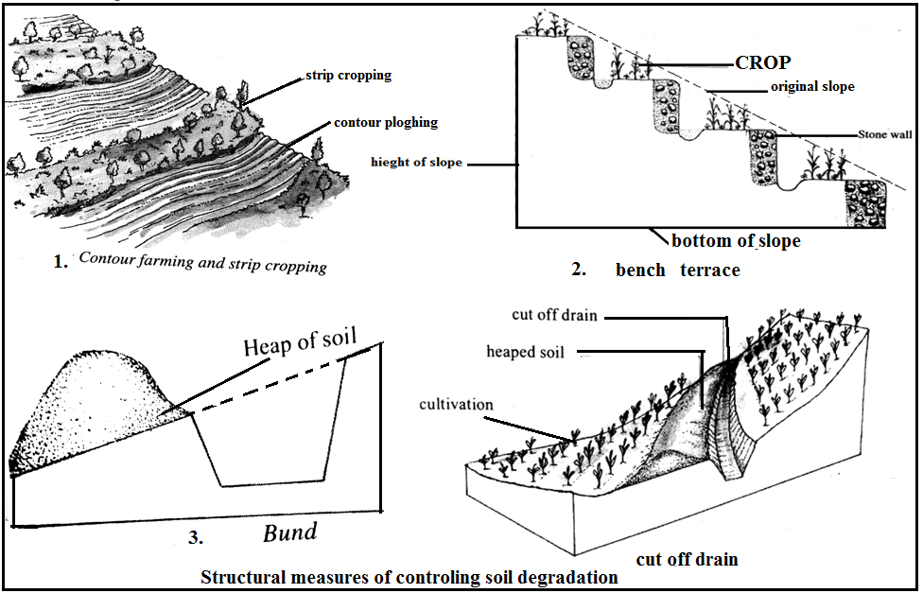

# UNIT 2 AGRICULTURE AND CLIMATE CHANGE

* **Climate change:** is the alteration of long term weather patterns through human activity.
* It has become an emerging issue requiring national, international and global attention.

**Ways of dealing with climate change in agriculture**

* Practicing Conservation agriculture
* Practicing Crop diversification
* Practicing Rain water harvesting
* Re-afforestation
* Agro forestry
* Practicing Integrated forest, crops, livestock and fish system

1. **Conservation agriculture**

* This is an approach in farming that strives to attain high and sustained crop production levels while at the same time minimizing the disruption of the soil’s structure, composition and natural biodiversity.

**Principles of conservation agriculture**

1. **Minimum soil disturbance**:

* Can be achieved through the following
* Direct seeding without mechanical seedbed preparation
* Slashing weeds in case they are present
* Selective use of herbicides at initial stage
* Growing cover crops that effectively smoothers the weeds by shading

**Importance of minimum disturbance**

* Helps to maintain the soil structure by making it less prone to erosion. Such soil will be more productive.

1. **Permanent organic soil cover**: soil covers refers to materials, especially vegetation present on the soil. Such materials includes cover crops and mulch.

**Soil cover has the following benefits**

* Improved infiltration of water hence reduced surface runoff and soil erosion
* Reduced evaporation of water from the soil hence less severe crop stress
* Moderation of soil temperature suitable for crop growth,
* Reduced crusting of the soil due to raindrop impact, that is hardened layer

1. **Crop rotation:** ensures maximum utilization of soil nutrients, by bringing them back to top soil thus they can be used by shallow crops. They act as biological pumps.

**Conservation agriculture deals with climate change in the following ways**

* Reduction of soil erosion, which in turn maintains soil structure and fertility. Siltation of water bodies like fish ponds and dams is also reduced
* Carbon sequestration by reducing carbon dioxide emissions into the air and accumulating more carbon in the soil thereby reducing greenhouse effects and consequently global warming
* Reduce vulnerability to climate change that can be brought about by soil degradation.
* Cleaner surface water as it reaches the streams more by sub-surface flow than by surface run-off

1. **Water harvesting**

* Water harvesting is the practice of trapping and accumulating rain water for future use. It is aimed at reducing loss of water through evaporation, runoff and deep percolation.

**Components of water harvesting**

1. **Catchment**: this is any surface from which rain water can be collected. Catchment range from foots paths road drains, rocks and roofs.
2. **Conveyance**: this is the means by which water moves from the catchment area into the storage structures.
3. **Storage**: this the most important part of rain harvesting. Rain water from roofs can be stored in tank.

**Water harvesting deals with climate change in the following ways**

* Irrigating crops during dry spell
* Recharging ground water sources
* Domestic use during the dry season
* Fire fighting

**Some rain water storage systems are**:

* Earth dams
* Rocks catchments
* Sand dams
* Farm ponds
* Water storage

1. **agro-forestry**

* It combines agricultural and forestry technologies to creates more diverse, productive profitable, healthy and sustainable land use systems.

**Agro forestry deals with climate change in the following ways**

* Reducing poverty through increased production of wood and other trees products for home consumption and sale
* Contributing to food security by restoring the fertility for food crops.
* Cleaner water through reduced nutrients and runoff.
* Countering global warming and the risks of hunger by increasing the number of drought resistant trees and the subsequent production of fruits, nuts and edible oils.
* Reducing deforestation and pressure on woodlands by providing farm- grown fuel wood.
* Reducing or eliminating the need for toxic chemical
* Through more diverse farm outputs, improved human nutrition
* In situations where people have limited access to main stream medicines, providing growing space for medicinal plants.

1. **Crop diversification**

* Is the growing of more than one crop by the farmer within the same growing season?
* This is done to reduce the risk of total crop failure as a result of drought, floods, pest and disease outbreak.

**Some crop systems that achieve diversification include:**

* Mixed or intercropping
* Strip cropping
* Relay cropping

1. **Re-afforestation**.

* Is the act of planting trees in areas where the trees were cut?

**The following are some of the reasons why trees are important**

* They use carbon dioxide and give us oxygen
* They help in preventing and controlling soil erosion
* They help to conserve water
* It also improves biodiversity as it brings ecosystem in which different fauna and flora will once again live symbiotically with each other.

1. **Intergraded forest, farm and fish systems**

* This is system made up of a range of resources saving practices that aim at achieving high production levels while preserving the environment.

**The components involved include**

* Livestock
* Crops
* Trees
* Fish

1. **Livestock**

* Livestock dropping are used as manure which provides nutrients to crops. This reduces cost of production since there is a little or no purchase of fertilizer.
* Organic matter which improves the soil structure thus reducing the degree of soil
* Energy in the form of biogas for household use. This is remedy for deforestation and climate change.
* Livestock dropping can be applied to fish ponds which stimulate the growth of plankton which is feed for fish.
* Livestock are important for their products such as meat, eggs, milk and wool among others
* Draught animals such as oxen and donkeys can be used for ploughing, transportation, operating mills among others activities.

1. **Crops**

* Crops remains can be used as livestock feeds
* Crops provide food for the household and for sale
* Some crops are pest repellents hence less pesticides is used
* Crops provide grains and nector for making honey by bees
* Cover crops protects the soil from erosion

1. **Trees**

Trees are beneficial in the following ways

* They provide timber for building
* They provide on-farm wood fuel
* They are source of fruits that add to the diets of the household
* They are a source of pollen grains and nector for making honey
* They are source of fodder for livestock
* They act as wind breaks, thus control damage to farm structures
* They play an important role in carbon sequestration reducing the green house effects
* They conserve soil moisture by reducing evaporation

1. **Fish**

* A variety of fish can be kept in farm ponds, fish cheap source of proteins for the households.
* Some fish such as tilapia (chambo) feed on mosquito larvae thereby reducing incidences of malaria.

**Mitigate:** reduce the impacts, **Flora:** a term to describe plant family, **Fauna:** animal

# UNIT 3 LAND DRAINAGE

* Land, which was formally under the sea, by means of complex drainage system. In our country there are many areas which are predominately swamps, which could become productive if drained.
* **Land drainage:** is the removal of excess water from the soil that hinders plants growth. It becomes necessary when the water table is high.

**Importance of land drainage**

* It controls water table to facilitates the growth of most agronomic and horticultural crops
* It improves soil aeration which is essential for root growth and the uptake of nutrients and water by plants.
* To raise the soil temperature which enhances seed germination and subsequent root and shoot development
* It enhances microbial activities which are essential for decomposition of plants
* It reduces incidence of soil and water borne peat and diseases e.g. malaria and bilharzia
* The soil becomes easy to work with. Soils which contain excessive water sticks the farming implements like hoes, disc ridgers, disc harrows.
* It helps to reclaim land and increase farmable land. The Netherlands (lands below sea level) reclaimed land from the sea and turned it into farmable land.
* They help to prevents flooding is redirected to its natural waterways.

**Methods of land drainage**

* Three main land methods of land drainage exists and these are;

1. **Surface drainage**

* The removal of excess water from natural rainfall and irrigation.

**Surface drainage takes one of these forms.**

1. **Open ditches**

* This is the most widely used method for removing excess water from a field. U or V-shaped open ditches are constructed. They must be deep and wide enough in order to be effective.

**Advantages of open ditches**

* Large quantities of water can be easily be drained
* It is cheaper to use

**Disadvantages of open ditches**

* It has high maintenance cost
* Interferes with agricultural mechanization
* It takes off valuable land used for planting crops
* Soil erosion may arise if ditches are not well designed.

1. **Cumbered beds**

* Involves making large heaps of soil form of big and broad ridges or mounds on which crops are grown.
* Water collects and drains into the space between mounds allowing crops to grow well on the mounds soils. Water flows away through the spaces between the ridges or mounds by gravity.

**Advantage of cumbered bed**

* It intercepts water that flows literary down the slopes
* Excess water is charged from the land making it is suitable for crop growing
* It is the easiest and cheapest method of reclaiming a swampy area.

**Disadvantages of cambered bed**

* High maintenance cost due to constant repairs
* It can be a form of breeding place for mosquitoes
* Perennial weeds establish themselves in the drain
* It causes some difficulties in using farm machinery
* Farm animals can injure themselves in the open ditches

1. **pumping**

* This is very costly method of drainage.
* It involves the use of pumps to conducts away water to areas where it may be needed.

1. **Sub-surface drainage**

* Uses underground porous pipes or ceramic tiles.
* These remove excess underground water, which lead to canal or river.

**Types of subsurface drainage**

1. **Mole drains**

* Mole drains are small tunnels constructed a few centimeters below the soil surface
* It is done by tractor pulling a cylindrical pug under the ground in a process known as **moling**

1. **French**

* Also called rubber or stone drains
* French drains are ditches dug to a depth of 60cm and filled with small and medium sized stones. The stones are then covered with trash and light.

1. **Porous**

* Short pieces of pipes about 30-40 long, are laces under the ground and run from end to end. They are gaps between the pipes to allow water to drain into them and conducted away.

**Advantages**

* Lowers the underground to prevent development of water logging caused by seepage
* It is not prone to gully erosion
* It does not occupy useful land
* It does not interfere with mechanical tillage operation
* It does not inconvenience animal movements on the field

**Disadvantage**

* It is costly to construct underground drains and they require proper maintenance
* Efficiency of this system can be impaired by blockage due to weed growth, silting up and farm waste
* Pipes and drains can be damaged by roots of trees or tillage machines such damage may not be discovered easily

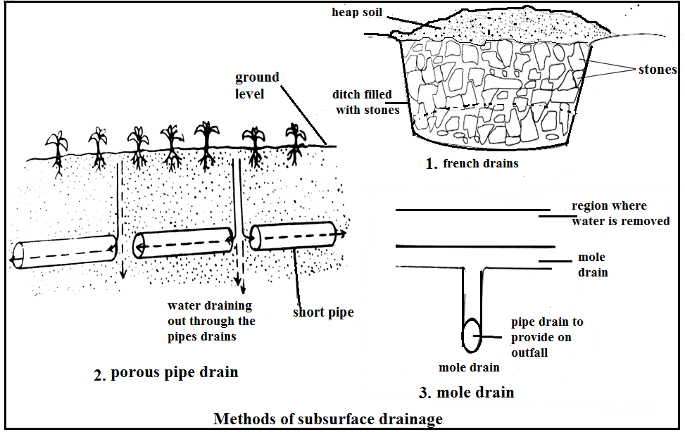

1. **Bio-drainage**

* Use of biological agent to remove excess water by plants or trees.
* Deep rooted plants, such as eucalyptus should be planted in marshy areas. Their roots penetrate deep in the soil creating waterways for the seep through.
* The trees also take up a lot of water which is then lost through transpiration.

**Benefits of bio-drainage over convectional drainage systems**

* Trees acts as wind breaks and shelter belts in agro forestry system
* Some tree may give useful by products such as fodder and wood products
* Tree help to purify the atmosphere by taking in carbon dioxide and releasing oxygen in the atmosphere
* Trees reduce the problem of climate change by increasing the forest cover
* Trees help to moderate the temperatures of the surrounding areas
* The method combines both drainage and disposal of water hence no problem of drainage of disposal
* It is cheaper to maintain

# UNIT 4 FARM MECHANIZATION

* **Farm mechanization:** *refers to the use of power driven machinery and implements to carry out certain farming activities of agriculture*.

**Types of farm machinery**

* they are classified into two

1. human and animal-drawn implements
2. tractor drawn implements
3. **HUMAN AND ANIMAL DRAWN IMPLEMENTS**

* These are drawn by drought animals such as oxen, donkeys, etc. they are commonly used by smallholders farmers.
* They are cheap to maintain. Common examples of animals drawn implements are ox-carts, mouldboard plough, ridgers, hand sprayers, hoe, panga knife.

1. **Ox-cart**

* Has two rears wheels and is mostly pulled by two animals harnessed by use a yoke.

**Uses of ox-carts**

* Transportation of farm produce.
* Transporting manure, farm inputs, people and water.

1. **Ox-plough**

* An ox-mouldboard plough is lighter than a tractor drawn mouldboard.

**Uses of an ox-plough**

* Ploughing
* Weeding
* Opening furrows in which seeds are placed during planting
* Harvesting crops such groundnuts

1. **Ridger**

* It us making ridges.
* It has two mould board fixed opposite each on the main beam.
* When pulled, the mouldboards make two soil heaps and a single furrow. A return pass completes the ridge making. A set of two or three ridges making mould board are assembled together.

1. **Hand sprayer**

* Used for spraying liquid chemicals to crops such as human drawn implements on farms in Malawi and their uses.

1. **Wheelbarrow**:

* transporting equipment,
* farm produce and
* Manure

1. **Hoe**

* Tilling

1. Panga

* Felling trees

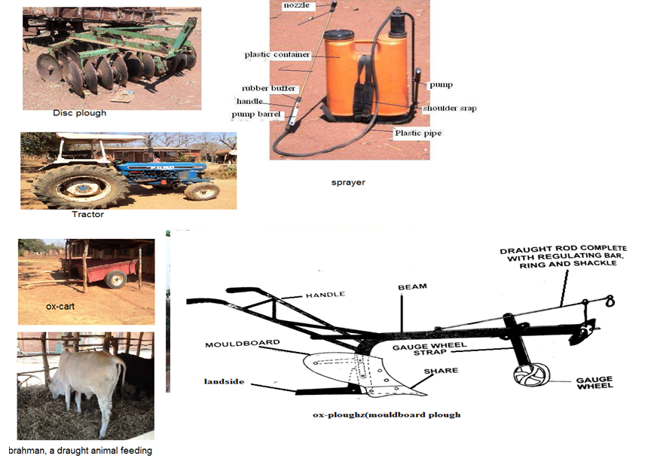

1. **Tractor drawn implements**

* These are implements attached to a tractor to carry out various operations.

**Examples are**: ploughs, planters, ridgers, trailers, cultivators and boom sprayers

* They need farmers with larger farm holdings.
* Smallholders’ farmers can also hire as a group and enjoy the fastness of the farm operation done by a tractor.
* Each implement is attached to the tractor different depending on its design.

**Ways of attaching (hitching) an implements to tractor. These are:**

1. **Single point hitch (drawbar)**

* Attached implements has its own wheels for support
* Hitch pins are used to fit the implement on the tractor
* They are also called pulled type of hitching
* Example: trailers,

1. **Three point hitch (hydraulic system)**

* Implements are attached at the two side links and top links
* They are also called fully mounted or integral types. Such implements do not other supports.
* They are lifted from ground by the hydraulic system.

1. **Power take off (PTO)**

* Implements are driven by power take off shaft or belt and pulley, which are in turning motion.
* The implements are attached at rear end of the tractor and are driven by engine power.
* PTO may be used to operate in reciprocating mowers, rotavators (rotary cultivators) and sprayers.
* Some implements are heavy and cannot be drawn using human or animal power. Mechanical power is required to pull them.

1. **Disc ploughs**

* Have 3 to 6 heavy concave discs of about 60-70cm. when ploughing the discs roll cutting furrows slices and throwing them sideways.
* Adjustments can be done, for example cutting angle by adjusting by pivoting them to and from the line of travel.
* The depth of ploughing is corrected by changing the height of the depth wheel or by adjusting the hydraulic system. Adding more weight on the beam also achieves this.
* The disc is ideal for tropical conditions, because it is bale to roll over objects or obstacles such as rocks.
* It is advisable that land be cleared of stumps and stones if moulded ploughs to be used.

1. **Harrows**

These are implements used for secondary tillage operations. Harrows are used for.

* Breaking large soil clods
* Mixing up soil
* Destroying weeds
* Leveling of seedbed
* Covering broadcast seeds
* Incorporate manure or organic matter into soil.

**Types of harrow**

1. **Disc harrow**

* Are similar to disc ploughs but their discs are smaller
* Disc can be either be plain or notched
* Several discs are assembled in one shaft forming a gang or tandem. And each gang may have 4 to 8 disc

1. Spike harrow
2. Spike tooth harrow
3. Zig-zag harrows.
4. **PLANTERS AND SEEDERS**

* These are implements used for planting. They open up the furrow, place the seeds in the furrows and cover them.

**Types of planters and seeders**

1. **Seed drillers:** they do not space seeds within the row but drop them continuously. They are used for planting tiny seeds like pasture grass and wheat.
2. **Precision planters:** they space the seeds according to the preset rate that is, measurement space from one seed to another and from one row to another.

* Planters can also apply fertilizers alongside the placing of seeds and covering them with soil.
* Can also be used for planting large seeds such as maize and beans.

**Care and maintenance of the planters is follows**

* Remove all seeds from the seeds hopper after sowing.
* Remove any stuck seeds in the seeds slots.
* Lubricate moving parts
* Fit the desired belt
* Dismantle the unit after use.

1. **Sprayers**

* These are driven by the P.T.O(power take off) shaft.
* They are used for spraying water soluble chemicals in crops fields.

**Ways of maintaining a sprayer**

* Empty the tank and wash the sprayer thoroughly.
* Replace filters and nozzles when necessary.
* Lubricates moving parts
* At the end of the season, remove nozzles and store separately and keep the sprayer under cover when in use.

**Harvesting machines**

* There are several machines used for harvesting various crops e.g. maize, groundnuts and wheat
* Forage harvesters are useful for harvesting pastures e.g. Napier grass. It cuts the crop into small pieces by use of the rotor which has two or four flails. The flails cut the crop as the tractor moves. The cut grass is directed into a container by a chute and flap.

**Factors to consider when mechanizing a farm**

1. **Size of the farm land.** Farm mechanizing requires large farms. It is economical for small and fragmented farm holdings that are common in Malawi. However, farmers can agree to combine their farms and hire government tractors.
2. **Availability of capital:** it requires sufficient capital to buy, install and maintain (spare parts)
3. **Topography of the land:** mechanization is easier on flat ground.
4. **Accessibility of the land:** the land should be accessible for ease of movement of machines.
5. **Technical know-how.** Mechanization requires skilled and qualified personnel to operate most machines, maintain and repair**.**
6. **Value of the crop:** the crops to be grown under mechanization should be of high value in order to recover the cost of mechanization.
7. **Market demand:** there should be high demand for the crops that are to be planted under mechanization.
8. **Farmers’ attitude:** farmers should have a positive attitude towards mechanization.
9. **Improved infrastructure and social amenities:** mechanizations require well distributed road networks, water supply and well-structured market system channels for various products.
10. **Availability of fuels and oils:** for proper operations and maintenance of machines, fuels oils should be accessible and affordable.
11. **Availability of labour:** it is essential that there is sufficient labor on the farm to perfect the work done by machines, and to do certain jobs that are best done by people.
12. **Land tenure:** this may limit the introduction of mechanization on the farm as it could prevent farmers combining farms to create a bigger farm holding.
13. **Lack of credit facilities.** These must be available as farm mechanization requires high capital outlay.
14. **Farming practices:** traditional farming practices may limit the size and efficiency of machinery to be used on the farm.
15. **Land for livestock feed:** where ox-drawn implements are used, there must be sufficient land for pasture production.

**Advantages of farm mechanization**

* It is time saving as operations are fast and at the right time. This allows the farmer to prepare the land, plant and harvest in good time, this will increase yield.
* Farm mechanization exploits the economies of scale of large scale production.
* Farmers can do jobs which otherwise could be difficult, such as clearing large forest areas or cultivating when the soil is too dry.
* Mechanization releases farmers’ time for other tasks
* Crop quality is increased especially during harvesting and processing.
* Farm operations are done more efficiently.
* Mechanization substitutes expensive farm labour.
* Mechanization compensates for labour peaks.

**Limitations of farm machinery**

* It creates unemployment due to redundancy of unskilled farm labour resulting in people migrating to cities and towns. This happens when mechanization is unbalanced, causing labour surpluses.
* Quality of work may be compromised due to the speed of operations.
* Capital and operating are very high.
* Foreign currency is lost in importing spare parts.
* Requires skilled and qualified personnel to operate most machines who require high wages.
* Farm mechanization may leads to soil compaction. This lead to poor drainage and poor development in the compacted soil.
* Some crops are not easily mechanized and this limits the choice crops to be grown.
* Availability of fuel to run the machines may not be available on the farm the cost may be high.
* Small land holdings make the mechanization uneconomical since mechanization requires larger farm holdings.

**Importance of maintaining farm machinery**

* the machine lasts longer
* Properly maintained machinery worked better and is safer to work with.
* Machines are too expensive for farmers to replace them frequently.

**Procedures for maintaining farm machinery**

* Put each implement to its proper use and use each implement correctly.
* Clean the tools and implements after use.
* Service the machines regularly by changing the oils and the filters
* Lubricate all moving parts to reduce wear and tear
* Repair broken parts
* Sharpen blunt parts
* Grease the share and mould board, as in plough or Ridger.
* Repair worn out parts e.g. in share mould board, hubs, bearings, yoke, tyres.
* Make necessary adjustments e.g. to the depth wheel of a plough or Ridger.
* Clean tanks of sprayers thoroughly with clean water.
* Dismantle and clean nozzles of sprayers.
* Store sprayers in a dry place
* Check the pressure in the tyres e.g. in an ox cart
* Paint the implements once in a while and store them in a shed to prevent rust.

**Maintenance of tractor drawn implements**

Make sure that tractor is properly maintained and regularly serviced by ensuring that.

* There are no oil leaks
* Steering and breaks in good state of repair
* The tractor has enough fuel
* Grease is applied to all greasing points on the steering links
* Bolts and nuts are tightened
* The gear box oil is topped up regularly
* The tyres are the correct pressure
* The plates in the battery are covered by acid(add distilled water if the acid level is low)
* There is enough water in the radiator and that the cooling system does not leak.
* The engine oil is regularly replaced together with the oil filter and cleaner.

**Safety measures when using farm machinery**

* Read operations manual that accompanies implements and machines before using them.
* Do not wear lose clothing such as neckties when operating the machines
* Do not leave the machines running unattended.
* Do not try to free a stalled blade before running the power off.
* Wear protective clothing such as overalls, breathing masks, gloves and boots during spraying.
* Do not overload the wheel barrow and ox-cart, to prevent them from overturn .wash you’re thoroughly with soap after spraying.
* Do not smoke or eat when spraying crops.
* Avoid spraying against the wind
* Empty chemical packets or bottles should be properly disposed of
* When carrying implements, ensure that the sharp blade face downwards to prevent accidents
* Keep children away from working machines
* Do not touch the given when it is hot or running.
* Do not remove the radiator cap when the radiator is hot or boiling, and avoid pouring cold water into a radiator when it is hot
* Check the steering and Blakes of the tractor so that they do not fail.
* Clean spraying equipment thoroughly
* Store chemicals in a safe place, out of reach of children and away from food stores.
* Do not use any left over.
* Make sure that all machines are properly mounted on the ground before use.
* Keep hands safe during cutting procedures
* Always wear safety goggles in metalwork.

# UNIT 5 FARM POWER

* Farm power is useful as it increases efficiency and effectively of work.
* **Farm power/energy**: is the ability to do the work

**Sources of farm power**

* Human power
* Animal
* Wind
* Mechanical
* Water
* Solar
* Biogas

1. **Human power**

* It refers to the use of human beings to do the work on the farms
* Human power is used to operate small tools such as machetes, axes, slashes, hoes, chaff cutters and simple pulleys.

**Advantages of human power**

* It can be motivated to increase productivity
* There is no fuel consumption
* It is cheap and easily available
* It does not require the presence of the farmers during operation

**Limitations human power**

* It is slow hence takes a lot of time to complete a task
* Low work output
* It is unreliable since it depends on the health of the workers
* It relies on the level of the skill of the worker
* Less motivation can reduce productivity

**Ways of improving human power**

* Output from human power can be improved through
* Proper training
* Use of efficient machinery
* Proper motivation
* Assignment of duties according to expertise

1. **Animal power**

* Draught animals use the energy for pulling implements and ox-carts used for transportation. They also using the moldboard plough.

**Power output of an animals is influenced by**

* Body weight of the animals: a draught animal can pull 10-20% of its body weight for six to eight hour
* Harnessing of the animal: properly harnessed animals will be comfortable and this enables it to work for long hours
* Training of animal: well-trained animals give out more power and are very effective.

**Advantages of animal power**

* It is relatively cheap to buy and maintain draught animals
* It results into higher work output than that of human power
* It does not require use of highly skilled personnel
* It be used where land is not accessible by tractor
* It can be used on small piece of land
* It can be used on steep slopes

Limitations of animal power

* Animals are likely to fall sick and may take long time to recover
* Animals get tired quickly
* Animals require adequate feeding in order to work well
* More land is required for pasture production
* Some animals may be aggressive resulting into injuries

1. **Wind power**

* Rotation of windmill produces wind power. Wind power is used for the following farm operations
* Pumping water for boreholes
* Generating electricity
* Winnowing of crops such s beans, millet and rice soon after harvesting.

**Advantages of wind power**

* It is inexhaustible
* Equipment used in harnessing wind power have low maintenance costs
* It is environmentally friendly

**Limitations of wind power**

* Wind power is unreliable
* Its direction cannot be controlled
* High initial costs in setting up a windmill
* It is limited to areas where wind is prevalent

**Ways of improving output from wind power**

* Increasing the size of the motors used in wind turbines
* Ensuring that wind turbines are operational and available

1. **Water power**

* Moving water has kinetic energy. This energy is used to
* Drive water mills which are used in grinding of cereal crops\
* Transport or ferry logs in navigable rives
* Operate a hydro pump to draw water for domestic use

**Advantages of water power**

* It is cheap
* It has low initial investments
* It is a renewable source of power

**Limitations of water power**

* Most rives are seasonal and have low volume during dry seasons. This lowers the power generation potential
* Rives flowing in relatively flat areas have low power generation

**Ways of improving output from water power**

* Construction of dams which can hold a large volume of water
* Use of modern efficient turbines

1. **Biogas**

* Uses animal dropping produce methane gas

**Advantages of biogas**

* It is environmentally friendly since it used wastes products
* It is cheap to generate once the biogas digester is installed
* The slurry(residue) is also used as manure
* It has low maintenance cost

**Limitations of biogas**

* High levels of skills are required for its installation
* It is more appropriate where animals are reared under zero grazing
* It is labour intensive
* It requires large quantities of raw materials
* It requires relatively high installation costs
* It is limited to a few farm operations

**Ways of improving output from biogas**

* Feeding the bio digester with manure which is high in solids. Microorganisms need this solid to produce the gas.
* Use of well-maintained bio digester

1. **Mechanical power**

* This drives machines for both primary and secondary tillage operations. This power originates from fuel which through combustions energy is released to drive the machines.

Forms of mechanical power

1. **Hydro-power**

* This the electric energy generated from flowing of water

1. **Geothermal power**

* Power generated by super-heated water coming from the earth’s core to the surface

1. **Nuclear power**

* Also known as atomic energy. It is derived from the alteration of atomic structure of radioactive elements like uranium.

1. **Storage battery**

* This is the stored electrical energy which is later used for lighting, cooking and driving small motors.

**Ways of improving output from mechanical power**

* Use of well serviced machines
* Ensuring that the input is high. For example, for hydro-power to be effective, the amount of water should be adequate.

1. **Solar energy**

* It is harnessed from the sun using solar panel.
* They are two form of solar energy

1. **Heat energy:** this may be used to dry crops such as cereal grains. It is also used for cooking and heating. Special equipment are used to trap heat energy
2. **Light energy:** solar panels are used to trap solar rays and convert them to electrical energy. The stored electrical energy may be used for pumping water, heating water for domestic use, cooking and lighting.

**Advantages of solar power**

* It is inexhaustible
* It is readily available, especially in the tropics
* It is environmentally friendly

**Limitations of solar power**

* It is unreliable. During cloudy days or days of low sunlight intensity, it is not possible to harness adequate solar power
* It is relatively expensive to install
* It requires special skills to install and maintain
* It cannot be used directly in most farm operations, light ene4rgy has to be converted into electrical energy before use.

**Ways improving output from solar power**

* Use of high voltage solar panels
* Protecting the solar cells from rain, snow, hail; and bird dropping
* Placing the solar panel perpendicular to the sun’s rays

# UNIT 6 GENDER AND AGRICULTURAL TECHNOLOGY

* **Gender:** refers to the condition of being a male or female and its associated roles as assigned by one’s society or culture.
* **Gender bias:** refers to favoritism due to prejudice, which results in discrimination against one gender.

**Examples of gender bias in agricultural technology**

* males driving tractors and oxen
* women processing farm produce

**Men are favored technically in agriculture than women due to the following reasons**

* Land tenure is in favour of men leaving women landless and father passes their land rights to sons not daughters.
* Men should work with machines as results women are left out to drive machines even if they are capable of doing so.
* Lack of access to loans as women are sidelined when it comes to loans and collaterals.
* Lack of confidence. Women do not want of take risks for fear of unknown and this put women in awkward position when it comes to try new machine.
* Lack of education, most women drop out of school before they acquire enough skills to take them through life.
* Lack of proper role models. Most girls do not see many women performers to emulate them.
* Female headed households. They are disadvantaged despites the, having to look after big families.

**Causes of gender biases in agricultural technology**

* Men are favoured with technology information and this is attributed to free mobility of males as compared to females.
* Parents perceive the benefits of education favors the boy child; this puts boys at an advantage in understanding technology.
* Most agriculture extension workers are males; these workers make more contacts with males famers than female farmers. This leads male farmers favored in receiving advice from agriculture extension workers.
* Men farmers have more access to capital as they assume the head of the household as such they control capital items.
* They are discriminatory attitudes and gender stereotypes. Money lenders are more comfortable transacting business with male farmers. Men can acquire and use improved technology.
* There is prejudice against females in the use of various types of farm technology as there is anticipation for men do drive tractor plough the fields with ox-drawn implements unlike female counterparts.
* Men generally look more confident with technological items. it’s simply because of the association with technology since childhood
* Boys often see their elders on the ox-carts or tractor, driving tractors, cars. They would want to do same the same in future.
* People believe that men are risk takers.

**Future’s wheel on the effects of gender bias in agricultural technology**

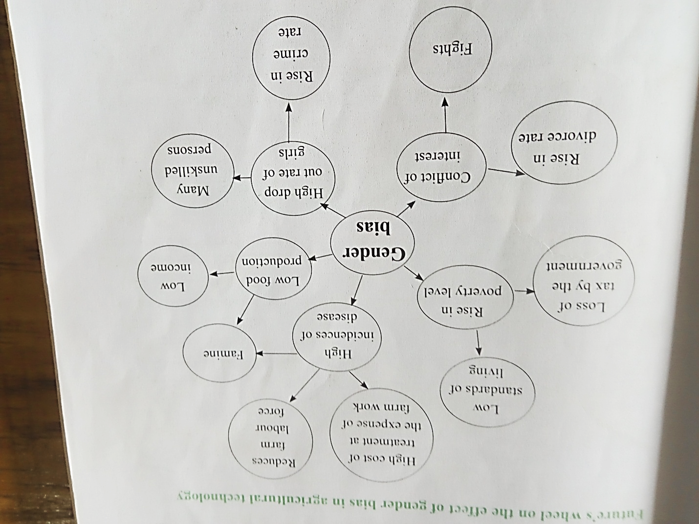

**Effects of gender bias in agricultural technology**

* **Low contribution from one gender to agricultural production.** About 50-70% of the all farming activities are conducted by women yet they depend on hand hoe, as a results, although their involvement in farming is high, their contributions is low.
* **Low agricultural productivity:** and this is due their dependence on unimproved technology, which is a result of gender bias.
* **Food insecurity, starvation and low energy output.** Due to low yield, there may be food insecurity at households or even national level. The family will face hunger, malnutrition and starvation. Farmers will be weak and therefore lack of energy or strength for farm

**Ways of dealing with gender bias in agricultural technology**

* Increase women participation in decision making and this in turn improves women status.
* Empowering women socially by giving them access to education as education is power
* Increase representation of women in power structures and decision making in their communities will politically empower them
* Invest land or capital in women to improve their economic base.
* Our culture has to change for agriculture to develop. This should include, giving women rights to landownership and management.
* Enlighten the community on the many contributions women can in make agricultural developments and view them as partners and not as subordinates.
* Developing documentaries for the print and media, on successful women farmers, serve as role models to would be upcoming women farmers.
* Review land and property ownership. This will ensure women own land and property.
* Level the political fields so that women can be involved in decision making to matters pertaining gender parity (equality).

# UNIT 7 IMPROVED FARMING TECHNOLOGY

* **Improved farming technology:** *refers to any techniques that are used in agriculture with the aim of improving high yields and protecting natural resources*.
* Involves a wide range of modern equipment’s, techniques and production inputs in order to increase and sustain agricultural productivity through land management and conservation.
* **Aquaculture:** the practice of raising animals that live in water such as fish.

**The following are some of improved farm technology**

* **Agro forestry** which helps to increase crop yield which in turn boosts food supply and makes people secure.
* **Farm mechanization** enables the farmer to complete all farm operations in time. This helps farmers obtain high yields.
* **Rainwater harvesting:** involve collection of water for storage which in turn can be used for irrigating crops and enables the farmers to harvest more even in cases on low rainfall.
* **Irrigating technology;** such as drip or basin irrigation**.** This enables farmers to have enough food even in drought periods.
* **Crop and animal breeding:** the development of high-yielding varieties and breeds of animals of enabling the farm to yield a lot of produce.
* **Fertilizer production:** has enables farmer to use fertilizer that is able to supply the soil with the major nutrients like nitrogen, phosphorous and potassium e.g. urea and 23:21:0+4s. This has enabled farmers to produce a lot of food, thereby ensuring food security.
* **Conservation agriculture:** such systems include zero tillage and organic farming. These have allowed farmers to increase and maintain productivity of the soil resulting in bumper yields.
* **Development of balanced rations:** has enabled the animals to produce high yields in form of meat, milk or eggs.
* **Improvements in animal housing systems:** farmers are able to feed and monitor the performance of animals and correct if it is poor thereby increasing their productivity.
* **Pesticides development:** has resulted in the development of pesticides or fungicides and best ways of controlling them. Crops and animals are now protected, resulting in high yields.
* **Herbicide development:** there are chemicals that are able to kill weeds before they cause damage to our crops. This enables farmers to produce bumper yields.
* **Agro-processing and packaging:** perishables such as fruits, meat and fish can be processed and kept in tins so that they are stored for a long periods and released when demand is high. Packaging enables products to stay longer and attracts customers.
* **Improved storage facilities:** post harvesting losses have been reduced due to the development of modern storage facilities such as metallic grains, silos, fridges, cold rooms etc.

**Improved technologies increases food supply through the following ways**

* **Cultivating large land holdings** and complete farm operations in time and this is accompanied by abundant harvests.
* **Good land husbandry** since each land is used according to its capability and this is called site-specific management or specific agriculture. In this way land cannot be subjected to land degradation but rather used it is being used sustainably.
* **The use of seed technology** ensures that farmers produce more yields than the use local varieties.
* **The use of conservation agriculture** makes it possible for crops to survive even when there is dry spell which under normal circumstances, a crop can wither and die.
* **The use of fertilizers boosts** crop growth and yielding.
* **Pest and disease management** involves suppressing pests to a level where they cannot cause damage to crops
* **Crops system** which ensures availability of a wide variety of crop (crop diversification). The farmers assured that the combined yields from all the crops will provide a high food supply.
* **Good livestock management**. When animals are providing with proper feeding, housing and medication, they produce highly for the benefits of the farmer.
* **Aquaculture engineering** implies construction of ponds for fish farming
* **The use of genetically modified organisms** (GMO) a genetically modified organism is an organism whose genetic material has been altered using genetic engineering techniques. Examples include bacteria and yeast, insects, plants, fish and mammals.

**Ways in which improved farming technology affects food security**

* It leads to increased food production and of wider diversity hence planned diet. This helps to eliminate hunger and malnutrition, increasing labor productivity and better lives.
* Safeguards on the encroachment of fragile land and forests as it ensures high production per unit
* Reduce human wildlife conflicts as pressure on grasslands and forested areas is greatly reduced.
* Greatly reduces post-harvest loses due to advanced crop handling facilities and processing technology.
* Reductions of greenhouse gas emission as fever machinery are used to till the land. This safeguards on climate change and hence more food production
* Agricultural research processes produce stronger seeds and effective fertilizer so that more food is produced
* Development of agricultural markets and expansions of trade enables farmers to sell what they grow at a profit.
* Availability of capital for farmers provides them with an opportunity to expand their farms and buy proper equipment’s
* Provision of extension services to farmers helps them to learn the best techniques of growing and strong crops. Food affordability is improved through optima production processes
* Educating farmers on sustainability agriculture provides them with knowledge on suitable methods that can be used to increase crop production without deleting the natural resources. This enhances sustainable farming where high production is coupled with environmental protection.

**Food security:** refers to the availability of food and one’s access to it

# UNIT 8 AGRICULTURAL MARKETING AND TRADING

* **Marketing**: is the transfer of goods and services from point of production to point of consumption.
* **Trading:** refers to buying and selling usually for a profit.
* **Marketing functions:** are activities performed in accomplishing marketing process

**Types of marketing functions**

1. **Exchange functions**: consists of buying and selling
2. **Physical:** assembling, grading, processing, packaging, transposition and distribution, storage, displaying
3. **Facilitating**: comprises of standardizing and grading, financing, risk taking, securing marketing information, and promotion and advertisement

**Differences between marketing and trading**

|  |  |
| --- | --- |
| **Marketing** | **Trading** |
| Concerned mainly with satisfaction of the consumer | Concerned mainly with the total sales |
| Involves numerous processes hence very wide | Involves only buying and selling hence not wide |
| Produces after though research to determine what the consumers wants | Uses resources to buy and then sell at profit |
| Produces to the market demand and makes some profits | Aims at making profits by disposing any surplus commodity |

**Marketing channels and agencies**

* **Marketing channel (distribution channel) =**it is the way products and services get to the end-user.

**Types of marketing channels**

* They are two

1. Direct marketing channel
2. Indirect marketing channel
3. Dual distribution
4. Reverse channel

**Roles of marketing channels**

* Links producers to buyers
* Influence the firm’s pricing strategies
* Affecting product strategy branding, policies, willingness to stock
* Customizes profits, install, maintain, offer credit etc.

1. **Direct marketing channel:** commodities are transferred from producer to consumers directly without involving middlemen. It is also called one-**tier marketing channel.** It is beneficial to farmers who can set price for their products

**Producer consumer**

**Advantages of direct marketing channel**

* Since small quantities of farm products can be sold, small producers can participate.
* The farmers set the price and therefore can be profitable
* Payment is usually immediate
* Farmers receive immediate feedback from customers on products and services.
* Enhances distribution efficiency of the marketing system since there is direct contact between the producer and the customers.
* Increases the profitability of agricultural crops for the producers by minimization of marketing of marketing costs and the margin of the middlemen
* It removes social inhibition among the farmers when selling their produce
* It encourages additional employment for the producers and thereby enhancing their outcomes.

**Disadvantages of direct of the direct marketing channel**

* It is difficult to locate customers since they are many
* They are low volume of units’ sales
* The need for customers to be served and bad weathers can discourage them from attending the market.

1. **Indirect marketing channel**

* There is involvement of middlemen before the product reached the final consumer.
* As the channel increases, the higher the consumer pays for the product because there is marketing cost and profit is added to the farm gate price.

**Types of indirect marketing channels**

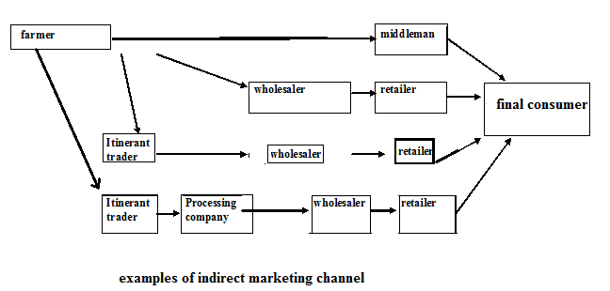

**Advantages of indirect marketing channel**

* It is easy to reach consumers because the length of the channel has been widened
* It is easy for existing channel to link up with other producers.

**Disadvantages of indirect marketing channel**

* Intermediaries may be unwilling or unable to sell products
* The intermediaries selling the products may be too costly

1. **Dual distribution**

* Describes a channel where Manufactures or wholesalers uses more than one channel simultaneously to reach the consumers.
* They may sale directly or uses other companies to resale and this may lead to channel conflict.

1. **Reverse channel**

* Under this one goods may go from consumers to intermediary to beneficially for recycling
* There is no consumer under this one but only the beneficially or user

1. **Electronic marketing channel**

* This has been developed due to advancement in technology.
* This makes use of internet to provide services for use by the consumers

**Marketing agencies**

* These are individuals or firms that are involved in the flow of goods from the producer to final consumers.
* Marketing agents may be;

1. **Government parastatals dealing with agricultural marketing e**.g. **ADMARC**
2. **Private companies or individuals**. These operates at different levels of the marketing chain, they include;

* **Retailer**
* Buy from wholesalers and sell to final consumers
* **Brokers**
* These are marketing agents who assists in selling or buying produce on behalf of producers or buyers at a fee.
* They are known as commission agents.
* They do not own any commodity but have specialized knowledge on market and market situation.
* **Wholesalers**
* These are individuals ,organization or companies
* **Processors**
* These are either government or private organizations.
* They process agricultural produce into finished products and sell to wholesaler.
* **middlemen**
* They buy from farmers and sell them to the ultimate consumers
* They can easily exploit farmers especially where knowledge on market situation is scanty.

**Roles marketing channels**

1. **Assembler’s e.g ADMARC**

* Buy commodities from farmers
* Store large commodities in their warehouse
* Provide transport systems which can transport and supply commodities far and wide so that all customers are reached.

1. **Producer**

* The starting point of every marketing channel
* Prepares commodities for consumers to buy in case for direct marketing channel.

1. **Processors**

* They process agricultural produce into finished products and sell to wholesaler.
* They also grade produce making it easier to assign price
* They add value so that consumers buy the commodity in a form of their convenience.
* Examples of processors: tobacco processors, Azam, Rab processors, Malawi Mangoes, Dariboard, NALI.

1. **Distributors**
2. **Retailers**

* Buy from wholesalers and sell to final consumers
* Sell the goods in any quantities required by consumers.
* Store the commodities in their warehouses.
* Provide information to consumers about commodity prices, impending scarcity of the commodity as well as receiving information from consumers and direct to the consumers.
* Provide a stop shop where consumers can get a wide range of commodities

1. **Wholesalers**

* Buy in large quantities from farmers or the processors and sell them to retailers
* Packaging for easy transportation and also to look presentable
* Advertisement so as to persuade consumers to buy the products at the expense of competing products.
* Sell their commodities in bulk but at lower profit because they take advantage of economies of scale.
* They bear the risks of price fluctuations, commodity deterioration, fire, theft etc.
* They carry out market research with middlemen can use as they link with the consumers

1. **Brokers**

* These are marketing agents who assists in selling or buying produce on behalf of producers or buyers at a fee.
* They are known as commission agents.
* They do not own any commodity but have specialized knowledge on market and market situation.

1. **Middlemen**

* They buy from farmers and sell them to the ultimate consumers
* Link the producers with customers
* They provide producers with the information about customer demand
* They provide input on loan to producers so that there is no bottleneck to prevent production like tobacco
* They provide a ready market for the commodities.
* They provide farmers with grading facilities so that the commodity cannot be rejected but sold at a high price. This occurs in tobacco production.
* They provide transport facilities so that the commodity can reach the market no matter how far away it may be in good times.

1. **Itinerant traders**

* This is vagabond who travels far and wide buying from all sorts of farmers whether with small or large quantities of a commodity.
* The aim is to build quantities large enough to sell in bulk to wholesalers.
* They buy all sorts of commodities such as crops and animals.
* They are seen to have mounted a scale with which to buy crop produce.

**Roles of marketing agencies**

* Provide reasonable analysis of marketing dynamics and key “lessoned learned”
* Review major marketing promotional moves by competitors and analyses effects on brand and category
* Identify key areas for improvements in previous year plan
* Proposes business-building projects with the potential to have a major impact on the brand’s business
* Outline key market research that may ultimately contributes to growth of brand’s business
* Recommended target audience and promotional strategies flow logically from the lesson learned with branding clients
* Propose a meaningful character for brand
* Communications with media towards achievement of objectives
* Accurate and timely communication-contact report, financial/budgets updates

**Difference between marketing cost and marketing margin**

* **Marketing costs:** these are costs incurred by marketing agencies for the service rendered in the marketing channel.
* **Marketing margin:** the difference between the retail price and the farm gate price or the differences between cost of buying and selling.

**Table below shows marketing costs and marketing priced received by each agency**

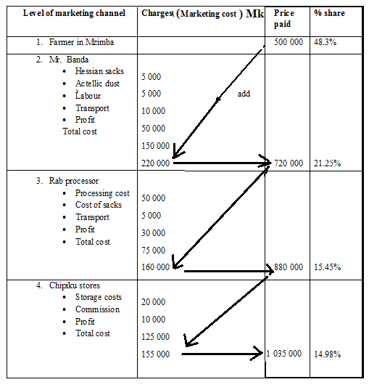

**Marketing costs**

* Money involves will depends on several factors such as
* Bulkiness of the crop
* Perishability which may call for special storage structures
* Distance between production and consumption
* State of the transport system
* Length of storage
* Process required
* Degree of packaging

**Types of costs**

* 1. **Variable costs**
* Costs which vary with the level of quantity of goods dealt with.e.g transportation, grading, packaging, repair, fuel, maintenance.
  1. **Fixed costs/overhead costs**
* Costs which do not vary in line with the quantity of goods handled. These are costs which are always incurred regardless of the quantity of goods handled.

**Solving numerical problems on marginal costs**

1. **Transport costs**

* The major marketing costs in agriculture since most of the commodities involved are bulky. The costs is grouped further in case the road is rough and earthen, making it impassable in the rainy season.
* **Costs of transport will include;**
* Depreciation of the vehicle
* Insurance
* Fuel costs
* Repair and maintenance costs
* Taxes
* Employment costs

**For example**

Transport costs for operating a 5 ton truck for 10,000km per year incurred the following costs

* Truck depreciation k40000 (**fc**)
* License k5000(fc)
* Insurance cover k75000(fc)
* Wages k45000(fc)
* Repair k100 000(vc)
* Maintenance k20 000(vc)
* Fuel k90 000(vc)

If the track handles goods of 80 tons per year, calculate the basic charge per

1. **Capital and financing costs**

* Capital goods are those that provides service overtime without getting exhausted. They include buildings, vehicles and machinery. These items loses value year after year due to tear and wear.
* The most common way of calculating depreciation is declining balance method.
* The formula used is as follows

**Where;**

is the depreciation in year i

RV is the value of the assets at the beginning of the year

R is the depreciation rate expressed as decimal

**Example**

The truck is worth k500 000 with the annual depreciation rate of 10%, calculate the depreciation in the second year

Year 1

Year 2

1. **Costs of products losses**

* Loss of products can occur at any point in the marketing chain. This could be during transport or processing. Losses could also be as a result of theft, spoilage, or attack by vermin (storage pests).
* Such loses could be expressed in monetary terms and used to calculate the marketing costs.

**Example**

The farm gate price of 1 tray of eggs having 30 eggs is at k3000. During transportation, an average of 5 eggs per tray are broken, thus the trader only sells 25 eggs. Calculate the cost of wastage on 1 tray.

**30eggs=lose 5eggs**

**k501**

**Marketing margin=**retailer price -farm gate price

**Retail price**= price paid by final consumer

**Farm gate price**= price received by the farmer

**Effects of population distribution on marketing**

* **It dictates the direction of flow of farm produce.** This means product will be taken to areas with large populations since they offer attractive markets.
* **It determines the supply of farm produce required in an area.** Highly populated areas require a lot of goods because demand is high for them.
* **It affects the means of transport used to take farm produce to markets.** In small population, farm produce are transported on heads, wheelbarrows, bicycles and ox-carts but areas with high population cars can be used due to bulkiness of produce being transported.
* **It affects the length of the distribution channel.** Low populations direct channel can be used while wider channels are used in areas with large populations.
* **It affects the form of products offered at the market.** Large population needs a variety of form to satisfy their needs.
* **It affects the demand of produce.** Densely populated areas have greater demand for produce compared to sparsely populated areas.

**Importance of trading of agricultural commodities**

* Trading occurs at three levels.

1. **Community level**

* A community can include a village or group of villages or larger.
* Members have a source of income when sell their commodity and this reduces the demand for white collar jobs.
* Buyers are assured of getting whatever they need in life even though they do not take part in production of the commodities.
* It promotes specialization which increases efficiency
* It increases productivity because the producer knows that what they produce will have a ready market.

1. **National level**

* People trade within the boundaries of their country. Products from part of the country can be distributed to the other corner of the
* It promotes comparative advantage whereby producers produce what they can perform best in their area
* It promotes the development of agro-based industries which process agricultural commodities
* It promotes productivity of various commodities because farmers are assured of market for their products.
* It promotes even distribution of commodities throughout the country to cover up those areas low or no production at all.
* It increases national output and eventually helps to reduce commodity prices so that the majority of people can afford to buy them.

1. **International level**

* People of different countries are involved in cross border trade.
* It encourages countries to earn foreign exchange necessary for the procurement of goods which the does not produce.
* It encourages producers to increase their level of production because they may have a much bigger market outside the country.
* Country can specialize in production on the basis of comparative advantage because they can still get from other countries goods they do not produce.
* Countries collect taxation from the goods they obtain from other countries. This increases national income.
* Consumers are provided with wide variety of goods from different countries. This creates competition among sellers which eventually encourages quality goods and services.

**Ways of improving trading of agricultural commodities**

1. **Community level**

* Improves road network so that both production inputs and outputs can easily be distributed to places of need.
* Increase productivity so that producers have surplus for sale to those who do not produce or have failed to produce adequately due to some reasons.
* Promote rural growth centers where goods services can sold or brought
* Promotes good neighborliness so that sellers and buyers can move freely from one village to another with fear of reprisals.

1. **National level**

* Improves transport networks(roads, railroads or even air transport)
* Promote national security so that sellers are not afraid of being robbed of their property.
* Provide adequate market information. this include prices for various commodities at different locations within the country so that seller can decides where to their commodities to for a higher prices
* Removing surtax on agricultural inputs so that the farmers can afford them and increase agricultural production.

1. **International trade**

* Improve neighborliness so that buyers and sellers can move freely across the borders.
* Improve transport networks. Malawi should be properly linked with its neighbours though neighbour roads, railways and airways and air for fast movement of her goods to and fro neighbouring countries.
* Provide adequate marketing information to improve importers and exporters about where good can be sourced and their prices.
* Reducing or even removing trade barriers. These are restrictions in form of huge surtax, quota, embargoes, exchange controls (importers are given restrictions on maximum amount of fore they can apply from banks), deliberately put in place to prevent importation.
* Improving quality of agricultural products so that they are attractive to the consumers
* Establishing a stable and competitive exchange rate. Devaluation of currency is good for exporters as the goods become cheap and competitive on the international market. For an importing country, it is bad because good become very expensive as result, goods coming from in will not be marketable.

# 

# UNIT 9 PRICE ELASTICITY OF SUPPLY AND DEMAND

* **Price elasticity of demand (PED or Ed**)= is defined as percentage change in quantity demanded divided by the percentage change in price
* Or the measure used in economic to show the responsiveness of the quantity demanded of a good or service to change in its price.
* In this scenario all determinants of demand such as income must be held constant.
* **Price elasticity of supply (PES or Es**) = is defined as percentage change in quantity supplied divided by the percentage change in price.
* Or is a measure used to economics to show the responsiveness of the quantity supplied of goods or service to change in its price

=

Where;

* is the change in quantity demanded
* is the change in price
* is the original price
* original price
* is the new price
* is the new quantity demanded

**Example**

Below is a demand schedule for oranges in market when price per kilogram is gradually reduced from **MK10 by units of MK2.**

|  |  |
| --- | --- |
| price (MK/Kg) | Quantity demanded |
| 10 | 200 |
| 8 | 300 |
| 6 | 400 |
| 4 | 500 |
| 2 | 600 |

**Calculate the price elasticity of demand when price falls from k10 per kg to k8 per kg.**

**Degrees of price elasticity of demand**

1. **Elastic demand. (**

* This happens when a small change in prices causes a larger change in quantity demanded.
* This happens when a commodity has direct substitute.
* In salima people would reduce demand for fish if fish prices go up and increase their demand for beef.
* Other examples of commodities with elastic demand include: orange, juice, coffee, honey, eggs and tomatoes.

1. **Inelastic demand**

* Demand is inelastic when a big change in prices causes small change in quantity demanded.
* Elasticity is less than one
* It occurs when consumers have little choice.
* For example a rise in maize prices may not have change in quantities people would be because maize is staple food.
* Other examples include the following: rice, millet, cassava, millets sorghum, salts and sugar.

1. **Unitary demand**

* There is proportionate change in quantity demanded.
* In unitary demanded elasticity is 1
* This occurs in situation when the commodity is fairly important in the life of consumers such as basic relief –beans, vegetables.

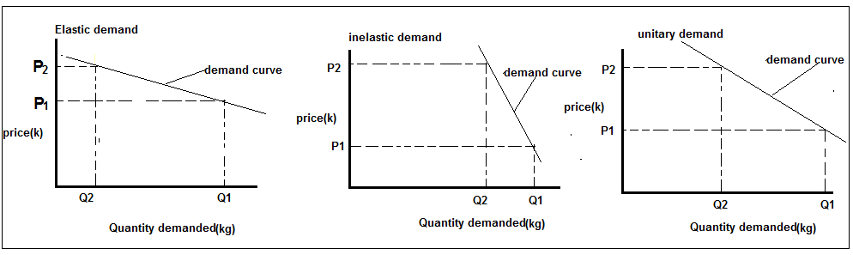

**Degrees of price elasticity of supply**

1. **Elastic supply**

* Happens when a small change in price causes a very big change in quantity of a commodity to be supplied on the market.
* Elasticity is greater than **1**
* In tobacco industry, supply is very elastic. A slight drop in prices makes a huge decline because many farmers pull out of the enterprises for fear of losing.

1. **Inelastic supply**

* This happens when large changes in prices causes a small change in quantity supplied on the market for sale.
* The price elasticity is less than 1
* Food commodities which are consumable and are storable behave like this. For example maize is irresponsive to change in prices soon after harvest.

1. **Unitary supply**

* Change in price brings a proportionately change in quantity supplied on the market for sale. The elasticity is 1

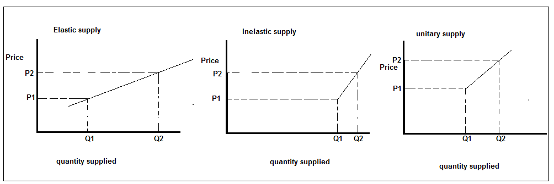

**Implication of price elasticity of demand and supply on agricultural commodities**

* When the demand is elastic, increasing the price will decrease farm income greatly decreasing demand.
* Similarly, reducing the alitle, increases farm income by greatly increasing the demand since consumers will rush to buy.
* When demand **is inelastic,** raising the price increases total income for farmer (seller) since the consumer has little or no choice but to buy the commodity.
* Similarly, reducing the price decreases the total income since the farmer is paid less for the same quantity price.Most agricultural commodities that are highly perishable such as vegetable and fruits have a relative more inelastic demand. (That is the demand is less sensitive to change in price).

**The price will vary depending on the supply.**

* If the supply is low, this will attract higher prices and hence and more income to the farmer.
* If the supply is high in the market, the price of the commodities drops and farmers may sell the produce at a throw away price. This negatively affects their income.

# UNIT 10 CROP IMPROVEMENT

* **Crop improvement means** increasing the productivity of cultivated crops by raising new verities which are more yielding than the present ones.
* It began with early farmers.
* They saw that some crops were superior and kept seed from those for the next growing season to maximize production.
* Plant breeding makes crop improvement possible.

**Aims of crops improvement**

1. To increase the average crop yield(quantity)
2. To improve the quality of the yield

**Crop improvement depends on two factors**

* Inherited traits (genetics)
* The environmental conditions in which crops is grown.

**Objectives crops improvement**

* **To increase the biomass** (adequate quantity of dry matter). This is attained if a variety has a higher rate of growth, greater plant vigour or incase with pasture ability to regrow very quickly after grazing or cut.
* **To improve partition**-ability to divert the biomass to the desired harvestable portions of the plant e.g. tubers for cassava and cobs for maize.
* **To increase resistant to diseases and pests** because these reduce yielding potential of crops.
* **To raise crop varieties that can survive in adverse environmental conditions** like drought, too much rainfall, heavy winds and adverse atmospheric temperature.
* **To achieve crop uniformity**. If the crops are of the uniform size, the farmer is able to determine in advance the amount and grade of yield expected from the field.
* **To develop varieties whose market value is required by the customers**? Such attributes could include ease of processing, storability and low caffeine content. Crop improvement must respond to the needs of the consumers.
* **To increase nutritive value of crops.** This reduces quantity of feed/food intake because a small quantity can provide adequately the amount of nutrients for normal body functioning.

**Activities**

1. **Collection of germplasm**

* Is the sum total of hereditary material, that’s is, all alleles of various genes present in crop species and its wild relatives.
* It is the basic material for launching a crop improvement programme

1. **Germplasm conservation**

* Conservation refers to protection of genetic diversity of crops from genetic erosion.
* There are two importance method of germplasm conservation

1. **In-situ conservation**

* Involves conservation of germplasm under natural conditions and this is achieved by protecting the area from human interference. Such areas include national park, biosphere or gene sanctuary.

1. **Ex-situ conservation**

* Is the preservation of germplasm in gene banks (artificial conditions). It can be done through the following ways

1. **Seeds banks**

* Germplasm is stored as seeds of various genotypes. Based on duration of storage, seed banks collection are classified into three groups.

**Base collection**

* These are seeds conserved for a long term (50-100 years). Is only distributed for regeneration

**Active collection**

* Seeds are store for medium duration (10-15 years). Such material are regularly used in crop improvement program.

**Working collections**

* Seeds are stored for 3-5 years. Such materials are regularly used in crop in improvement programmes

1. **Plants banks or field bank**

* This is an orchard or a field in which accessions of fruits or vegetatively propagated crop are grown and maintained

1. **Shoot tip banks**

* In this bank, germplasm is conserved as slow growth cultures of tissues of shoot tips and node segments. They are also referred as meristem cultures.

**Conservation of genetic stocks by meristem cultures has the following advantage**

* Each genotype can be conserved indefinitely free from viruses or other pathogens
* It is advantageous for vegetatively propagated crops like Irish potatoes, sweet potatoes and cassava
* Vegetatively propagated material can be saved from natural disasters
* Regeneration of meristem is extremely easy
* Plant species having variability can be easily be conserved by meristem cultures

1. **Cell and organs banks**

* **T**hey include germplasm collection such as embryogenic cell cultures, somatic or zygote embryo preserved at in liquid nitrogen.

1. **DNA banks**

* **.** This is where DNA segments from the genomes of germplasm accessions are maintained and conserved

1. **Germplasm evaluation**

* Refers to the screening of germplasm with respects to morphological, genetical, economical, biochemical, and physiological, pathological and entomological attributes.

**Aims of germplasm evaluation**

* To identify gene source for resistance biotic and abiotic stress, earliness, darkness, productivity and quality traits
* To classify the germplasm to various groups
* To get the significance of individual germplasm line

1. **Germplasm cataloguing, data storage and retrieval**

* Information on the species and variety names, place of origin, adaptation and its various attributes is well documented.
* Catalogues of the germplasm collection for various crops are published by the gene banks

1. **Actual improvements**

* Involves the transfer of genes for resistance to common disease from wild relative to cultivated species. It may also involve selection of seeds that have desired qualities from harvested crops.

1. **Demonstrations**

* It is carried out to prove advantages and adaptability of newly developed crops.

1. **Seed multiplication**

* This is carried out in the research farm as well as in neighbouring

1. **Seed distribution**

* **Seeds are distributed to farmers for adoption**

**Methods of crop improvement**

* There are three main activities involved in crop improvement

1. **Introduction**

* This involves importation of superior crop varieties from others countries into Malawi.
* This stocks serves as multiplication and propagation in the new area. For success, the ecological condition art the country of origin must be similar to the conditions where.
* Some crops which were introduced in Malawi from other countries include the following
* **Maize: Ukiriguru Composite A (UCA)** from Tanzania
* **Groundnuts:**
* **malimba** from Gambia,
* **Manipitar** and **mawanga** grown in lower shire and it is from Bolivia butcame toMalawi though Australia and Zambia
* **Rice**
* **senga(IET 4094) came to Malawi** from India in 1977,
* blue bonnet from United states of America in 1960s and remains the high yielding rice varieties in Malawi,

1. **Selection**

* This means choosing of superior plants that have certain desirable characteristics for breeding or propagation. Good farmer do this all the time
* In selection, plant breeders use the following techniques
* **Mass selection**
* **Pureline selection**

1. **Mass selection**

* This is selection of crops based on their phenotype and general performance
* Seeds from selected plants are bulked up for the next generation.
* It is most effective for highly heritable traits.
* The limitation of this methods is the there is a large influence of the environment on the development, phenotype and performance of **plants**

1. **Pureline selection**

* This involves three stages

1. Numerous superior plants are selected from genetically variable population
2. Progenies of the individual plants are grown and evaluated by simple observation frequently over a long period of time.
3. When the selection can no longer be made on the basis of observation alone, trial are undertaken involving measurements to determine whether the remaining selections are superior in yielding ability and other aspects of performance**.**

**Any progeny superior to an existing variety is then released as a new pureline variety.**

**Types of selection**

1. **Artificial selection**

* It uses human judgment to choose plants that appear superior. The breeder can choose a large number of plants or single plants for breeding purposes.

1. **Natural selection**

* The plants are given the same opportunity in controlled environment to survive. Some fail and die. Those that survive are then used for breeding.

1. **Hybridization**

* Two plants are cross pollinated to raise a new variety which carries characteristics from both parents.

**Stages in hybridization**

* 1. **Selection of parents**
* Depends on the aims and objectives of breeding
* Parental plants must be selected from the local areas and are supposed to be the best suited to the existing conditions.
  1. **Selfing of parents or artificial self-pollination**
* It is essential for inducing homozygosity for eliminating the undesirable characters and obtaining inbreeds**.**

**Advantage**

* It produces pure lines. A **pure line** always reproduces itself exactly (it breeds true)

**Disadvantages**

* Lead to loss of vigour of plants
  1. **Emasculation**
* Inbreeds are grown under normal conditions and are emasculated. **Emasculation** is the removal of stamen or anthers or killing of the pollen grains of flowers without affecting the female reproductive organs
* Emasculation is not required in unisexual plants but it essential in bisexual or self-pollinated plants**.**
  1. **Bagging**
* The emasculated flower or plants is immediately bagged to avoid pollination by any foreign pollen
  1. **Tagging**
* The emasculated flowers are tagged just after bagging. The tags are attached to the base of flowers with help of a thread.
  1. **Crossing**
* Artificial cross-pollination between two genetically unlike plants.
* In this method mature, fertile and viable pollens from the male parent are placed on the receptive stigma of emasculated flowers to bring about fertilization.
  1. **Harvesting and storing the F1 seeds**
* Crossed heads or pods of desirable plants are harvested and after complete drying they are threshed. Seeds are properly stored with original tags
  1. **Raising the F1 generation**
* The stored seeds are sown separately to raise the F1 generation
* The plants of F1 generations are progenies of cross seeds and therefore are hybrids**.**

**Production of single and double cross**

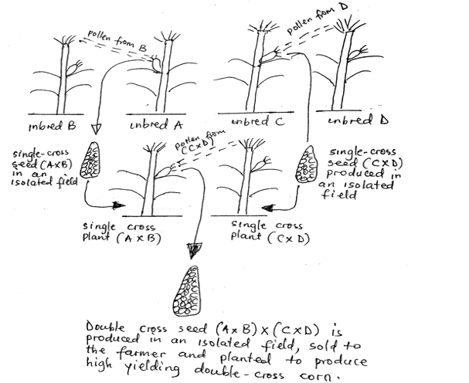

**Inbred:** is an offspring produced by mating closely related parents

**Hybrids:** are offsprings produced by mating of different parent plants

# UNIT 11 MANGO PRODUCTION

* The mango (*mangifera indica*) or Indian mango is a tropical evergreen tree which can reach 15 metres.
* It has a dense forage, producing a heavy shade which suppresses weed growth underneath

**Importance of fruits**

* Source of vitamins, water and minerals which boots immune system (vitamins A,B,C,E mineral such as calcium, magnesium,, iron, zinc, potassium and phosphorous)
* Provide a source of vitamins, minerals and water
* Farmers sell fruits for income
* Fruits can be exported for foreign exchange
* They are used a raw materials in some agro-industries to produce fruits such as mangoes in salima
* They are good source of laxative effect in our digestive systems, preventing the likelihood of constipation
* Fruits provide employment

**NB:** Many people are self employed or offered paid Jobs when they are in fruit production

in orchards.

**NB:** Although production level of fruits in Malawi is still low, fruits can provide a great deal

of foreign currency if they are exported to other c



**Varieties of Mangoes**

1. **Local Varieties**

* Boloma, Domasi, dodo, waka, kambululu, kapantha.
* Despite having good flavour, these varieties have a lot of fibres.

1. **Exotic Varieties**
2. **Haden**

* It is about 400-700g large
* Matures early
* Suitable for hot dry season
* They are well coloured with excellent flavour
* They are easily attacked by anthracnose disease.

1. **Zill**

* It is 300-400g in size
* Matures early
* Fruits are scarlet to dark red when ripe
* Suitable for all typical mango areas
* Have excellent internal quality

1. **Irwin**
   * Medium size of about 450g and 12 cm long
   * Early maturing
   * Suitable for most areas
   * Fruits are elongated and slightly flattish.
   * Has excellent internal and external quality
2. **Davis-Haden**
   * It is up to 900g large.
   * It is suitable for hot dry areas.
   * It is resistant to anthracnose.
3. **Palmer**
   * It is 600-700g large.
   * It is late maturing
   * Produces elongated fruits.
   * Easily attacked by bacterial black spot.
4. **Kent.**
   * It is up to 900g large
   * It is late maturing.
   * High yielding.
   * Suitable for hot areas.
5. **Tommy Artkins**

* Has a long shelf life
* It is tolerant to handling and transportation with little or no bruising or degradation
* Colour of the fruit is purplish and they are good for processing

1. **Keitt**
   * It is large up to 900g
   * It is late maturing.
   * It bears plump thick fruits.
2. **Anderson.**



1. **Anderson variety of mango**
   * It is 28 cm long and about 1kg large.
   * It is a very late maturing variety.
   * It is suitable for canning.

**When choosing a variety for an orchard, the following factors should be considered;**

* It must be high yielding.
  + - It must be resistant to diseases
    - It must have excellent internal and external qualities
    - It must be early maturing or the one that matures later than existing varieties in order to extend the mango season.

**Husbandry Practices for Mango Growing**

1. **Choice of Site.** Consider the following

* **Soil depth:** the depth should be deep to allow expensive roots development. A deep, fertile, sandy loam soil that drains well.
* **Well drained.** Soil should be free of water-logged.it should be of low water table.
* **Fertile soil:** a fertile soil should be selected for mango production
* **Slope facing sunshine;** grow on east-west slope. Mangoes do well in open sunshine. it is sensitive to cold.
* **Salinity:** mangoes have a low tolerance to salts
* **Altitude:** they do well at altitudes below 600m. the yields are low are higher altitudes, although, although some upland varieties can produce a reasonable yield at altitude as high as 1 500m
* **Rainfall** mangoes are drought tolerant, but need a maximum rainfall of 650mm per annum and dry period for flowering and fruiting. Rainfall during flowering reduces yields.
* **pH** optimum pH range 5.5-7.5

**b. Land preparation**

* + - Prepare planting holes (90x90x90) cm two months in advance.
    - Refill the planting holes with decomposed manure of about 5-10kgs.
    - Make spacing between planting stations 9mx9m but in infertile soils planting stations should be wider.

1. **Planting**

* **Transplant** is coming from “transfer and plant**”** seedling are transferred from where they were raised and planted on new site.
  + - Transplanting should be done at the beginning of the planting season for successful establishment.
    - Use sub soil left from planting holes to make basins around each tree to hold water
    - Water the seeding immediately after transplanting

**d. Mulching**

* + - This should be done to conserve the moisture by reducing the rate of evaporation.

**e. Weeding**

* + - Clear all the weeds around the basin
      * Slash the rest of the area regularly.

**f. Fertilizer application**

* + - * Mangoes are not heavy feeders but application of manure and fertilizers is necessary.
      * Apply 5-10kgs of manure at the beginning of rainy season
      * The amount of fertilizer applied varies according to age of the fruit tree and type of fertilizer.

**g. Harvesting**

* + - * Harvest physiologically mature fruits by hands and should not fall off on the ground to avoid bruising.
      * Fruits for export should be packed in trays of 5kgs each with 12-30 fruits in a single

**h. Pests of Mangoes**

**1. Mango Stone Weevils (*Sternchetus mangiferae)***

* + - * It enters the fruit during the early stage of fruit development.
      * It damages the seed
      * Fruits may fall off or rot or may have hard white areas in side.
      * The pest can be controlled by burying dropped fruits and keeping the orchard clean.

**2. Mango Scales ( *Coccus mangiferae*) and *Coccus acuminatus***

* + - * These are insects which attack the leaves, stems and fruits.
      * They produce sticky liquid (honey dew).

**They can be controlled by**

* spraying the trees with 20 WP at 85 g in 14 litres of water

**3. Fruit Flies (*Ceratitis capitata*)**

* + - * Flies lay eggs on the fruit
      * Shinny white maggots hatch and enter the fruits.
      * Fruits change colour before they are ripe.
      * Part of the flesh becomes liquid.

**The pest can be controlled by**

* Collecting and burying fallen fruits
* Spraying Fenthion 50EC at 1 ml per litre of water
* Harvesting fruits before ripening.

1. **Diseases of Mangoes**

|  |  |  |  |
| --- | --- | --- | --- |
| **Disease** | **cause** | **Symptoms** | **Control** |
| 1. anthracnose | **fungus** | * premature ripening of fruits * leaf spots(discoloration) * black spots on fruits * rotten of fruits | * spraying benoml(benlate) 50 WP at 15g in 10 litres of water every fortnight. * Remove dead branches, twigs and dead leaves * Use fungicides such as manocozeb starting at stage of flowering |
| 1. powdery Mildew | fungus | * shedding off of flowers and immature fruits * white substances appear on flowers | * spraying benoml(benlate) 50 WP at 15g in 10 litres of water every fortnight * spray Sulphur based fungicides |

# UNIT 12 CROP PROCESSING

* **Crop processing**: refers to all activities that are done with aim of changing agricultural items from one form to another.
* Some of the processing methods used by small scale farmers include
* Drying
* Fermenting
* Milling
* Juicing
* Processing methods carried out on larger scale
* Canning
* Emulsification
* freezing

**Importance of crop processing**

* Improves shelf life of the products making it possible to preserve the produce at times of surplus.
* Improves the taste of produce through addition of nutrients in processed food.
* Adds value to crops by preventing deterioration of their nutritive value
* Source of employment as people are employed in various units of processing plant.
* Source of foreign exchange when exported

**Processing of various crops**

1. **Processing of maize**

* Before the maize is transformed into a new form which can add value and improve taste, **the following should be done:**

1. **Dehusking:** Removing the husks by hand to speed up drying of the grains
2. **Shelling**: the removing of the grains from the cob. It speeds up the drying process.
3. **Drying the grain**:

**Reasons for drying the grains**

* prevents moulds developing on testa,
* it makes the taste hard to resists insect attack,
* it reduces respiration rate

1. **Cleaning**: this is done by winnowing to remove chaff
2. **Dusting or spraying pesticides;** protection against storage pests.
3. **Packing**: ready for marketing
4. **Milling:**

* The maize can now be processed into flour, animal, animal feed, beer, mbwibwi, maize products such as cornflakes.

1. **Processing groundnuts**
2. **Shelling: this** involves extracting the nuts from the pods
3. **Drying:**

* dried by placing them on a black mat and allowing the sun and wind to dry the grains
* When drying Cover with a cloth to protect it from insects and birds while drying
* Drying can also be done using forced air dehydrator, solar drier or electric drier on large scale

1. Cleaning: the dried nuts are then winnowed before packing in standardized bags for marketing.
2. **Oil extraction**: the clean dry nuts can be processed by oil pressing equipment into peanut oil, peanut butter and other products
3. **Processing mushroom**

* Mushroom are highly perishable.
* Mushrooms processing techniques include the following.

1. **Canning**

* This is the most commonly method of preserving mushrooms

**Procedure in canning**

* Grading
* Cleaning
* Blanching (pre-cooking). Mushrooms pieces are immersed briefly in boiling water
* Can filling in brine solutions
* Sterilization with heat and cooling through water supply
* Labelling the cans for storage

1. **Individual quick freezing (I.Q.F)**

* Raw materials are washed at processing units and then impacted
* Sliced and graded
* They are then blanched, water cooled and subjected to tunnel freezing
* They are then cooled in a system at temperature of
* They are then packed in multilayer polybag and stored in a cold storage at temperatures of

1. **Drying**

* This involves sun drying, mechanical drying, air drying and microwaves drying
* After normal drying, vacuum drying processes follows at 1.0 to 1.5 bars

1. **Pickling of mushrooms**

* In pickling of mushrooms, white wine, vinegar, salt, sugar, garlic and olive oil are mixed with water and boiled
* Mushrooms are then removed from the pan and completely dried
* Dried mushrooms are coated with olive oil
* Mushrooms can remain in good condition for about two months.

1. **Radiations preservation**

* Mushrooms are exposed to radiation of gamma rays to stop the post-harvest growth and deterioration.

1. **Processing mangoes**

* Mango are highly perishable hence they cannot be stored for long when ripe. They are best stored I n processed form. Mangoes can be processed into juice and chutney

**Mangoes can be processed using the following procedure**

* The fruits are cleaned
* They are then simmered in water in stainless, glass or enamel pot
* When tender, the fruits are cut into small pieces and pressed through a food mill or hand operated fruits press
* Lemon juice can be added to taste
* The juice is then frozen or canned for storage

1. **Processing of Amaranthus (Bonongwe)**

* Amaranthus are leafy greens. They may be harvested when abundant and preservedas dried vegetable or placed in a freezer.

1. **Drying**

* Can be dried in a home oven
* Leaves require blanching before drying (blanching is done by placing them in boiling water bath or in stream for about 2 minutes. This stops certain enzymatic reaction in the leaves and helps retain their colour and flavor)
* Prepared(blanched) leaves are placed on baking or metal screen trays
* Oven temperatures are set at and the doors left open 2 to 4 inches for ventilation. Drying time can be reduced if ventilation is increased

1. **Freezing**

* Amaranthus leaves are blanched (washed out) before freezing.
* Freezing temperature are set between
* Packages for freezing should be moisture proof and vapour proof with as little as possible to prevents oxidation during storage
* The packages are then placed in a freezer

**How to process cassava**

* Cassava is better processed by
* Peel and slice
* Soaking it for some days to remove cyanides
* Wash the cassava
* Dry it
* Process it into flour
* The flour can be stored in bags or baskets(madengu/mitanga)

# 

# UNIT 13 PASTURE

* **Pasture:** are grasses and other herbaceous plants grown and used as feed by grazing livestock.

**Importance of pasture**

1. Provide feeds to for livestock more especially ruminants as compared to commercial feeds
2. Controls soil erosion by creating a soil cover that protect soil from splash erosion
3. Improves soil structure. Through decaying of plants materials provides organic matter which binds soil particles together.
4. The leguminous pastures in crop rotations help to improve and maintain soil fertility s they are able to fix nitrogen in the soil. The nitrogen may be used by successive crop.
5. Add nutrients to the soil. Upon grazing nutrients circulate through the animal and back into the soil as dung and urine.
6. It helps in breaking the life cycle of pests and diseases when included in crop rotations Reduces pests and diseases. A good example is love grass and katombora Rhodes grasses are used in tobacco rotations to control eelworms.
7. Helps in reducing carbon dioxide concentration in the atmosphere by absorbing it, thereby preventing climate change.

**Types of pastures**

* Pastures fall into two major groups of pastures and these are

1. **Indigenous pastures**

* Are naturally growing grasses and legumes
* They establish through natural regeneration
* They are found in uncultivated grassland and dambos(complex shallow wetlands)

**Examples include the following**

* Thatching grass(tsekera)
* Angle grass
* Whiskey grass
* Rendel grass
* False love grass

**Indigenous pastures can be improved through the following ways**

* Introduction of suitable legume crop
* Application of manure at the onset of rains
* Regular weeding
* Controlled burning to remove fibrous stems after the grazing periods.
* Proper socking rate
* Harvesting pasture at the appropriate time

1. **Exotic pasture**

* This is pasture planted by man. It is also called cultivated pastures or pasture leys
* These grasses and legumes have high productivity compared to natural pastures.
* They have high dry matter and crude protein content

**Some commonly cultivated grasses include;**

* Rhodes grass, buffel grass, napier (elephant), guinea grasses

**Some commonly cultivated leguminous pastures includes**

* Pencil flower, butterfly pea, purple bush-bean, horse grain, tick clover, wild soya bean
* The following leguminous shrubs are also grown in some farms
* River tamarind, msangu

**Cultivated pastures can be classified into permanent and temporary pastures**

1. **Permanent pastures**:

* Is a cultivated pasture that contains at least one exotic species of grasses and that is managed for 10-15 years e.g. kapinga.

1. **Temporary pastures**

* Are cultivated pastures, usually lasting 3-5 years. They may consist of a **pure stand** of grass or legume or inter-planting of the two. e.g. love grass.

When establishing theses cultivated pastures, a farmer may plant a pure stand or a mixed stand

1. **Pure stand pasture**

* Only one crop is grown in a field. The stand can either be leguminous crops or grass crop.

**Advantages of pure stand pastures**

* It is easier to control weeds by herbicides
* Less competition for nutrients, space and light
* Easier to collect seeds from a pure stand

**Disadvantages of a pure stand pastures**

* In case for disease and pest outbreak the farmer has nothing to rely on unlike in mixed stand
* There is lower yields per units areas in comparison to a mixed stand
* There are more cases of bloat in animals if the pastures crops are leguminous

1. **Mixed stand pastures**

* Refers to establishment of leguminous crops and grass on the same piece of land.

**Advantages of mixed stand**

* Grass-legume pastures have higher nutrients value than either of them separately
* They improve soil fertility due nitrogen fixation by legume and hence less usage of nitrogenous fertilizer
* Higher yields per unit area are realized compared to pure stand pastures
* Animals are less prone to bloat when grazed on a mixed pastures
* There is guaranteed yields in case of failure of one crop
* Grass-legume is more palatable to livestock
* There is maximum soil exploitation as different crops have different soil nutrients requirements

**Limitations of mixed stand pastures**

* It is difficult to control weeds using chemical
* There is undesirable competition for nutrients, light and space especially when in collect seed rates are used.
* It is difficult to collect seeds from mixed pasture.

**Methods of pasture establishment**

1. **Broadcasting/scattering**

* Pasture seed is mixed with diluents such as and, saw dust or fertilizer and spread on the soil surface either by hand or using a fertilizer spreader and is then raked into the soil.

**Advantages**

* Easiest way of sowing tiny seeds as not much skill is required
* Large pasture fields can be established within a short a short period of time and this saves time
* It is cheap it requires less labour
* It is quickest way of sowing pasture.

**Disadvantages**

* some seeds can easily be eaten by birds or blown off wind
* some seed can be buried deep hence they fall to germinate
* some seed do not fall on desirable places
* plant population is not maintained a some seeds just get affected by bad weathers
* difficult to weed the field
* difficult to apply fertilizer

1. **Under sowing**

* The pastures are established under already growing crops e.g. maize. The maize is established first and the pastures are planted immediately after weeding the maize crop.

**Advantages**

* The farmer gets extra harvest of pastures from filed
* Allows the pastures to be established a year earlier
* It eliminates the costs of the land preparation for the crop pastures since the weeding for the maize crops clears the land for planting the pastures.
* First crop provides shade to the pastures so that it may not easily wilt soon after planting.

**Disadvantages**

* The yield of each crop is less than if it were direct planted or grown on pure stand.
* It is difficult to determine the right amount of fertilizers for the two crops.
* If the choice of two crops is not properly done, the first crop may end up suppressing the pasture, leading to a delay in completion of its establishment phase.

1. **Over sowing**

* Establishing a pasture legume in an existing grass pasture. Before sowing the legume in an existing pasture species need to be reduced by burning, heavy grazing or slashing. This give chance to the legume seeds to establish fully with minimum competition from the grass.

**Advantages**

* It improves the decomposition of existing pastures through the introduction of other desirable species.
* it increases the dry matter yield of indigenous pastures
* it increases the quantity of indigenous pastures in terms protein

**Disadvantage**

* The introduced species may face competition for sunlight and nutrients from already established pasture, unless the original pastures is reduced by burning or heavy grazing before over sowing.

1. **Vegetative propagation**

* This method uses stems cuttings (sets) or uprooted cutting(splits)
* Torpedo grass, star grass, bushman Mine panic is established from splits
* Napier from sets
* Cutting should be planted soon after chopping

**Advantages**

* Vegetative organs have sufficient food reserves to help the young shoots to become established.
* It ensures genetic uniformity in pastures as all offspring’s will resemble their parents
* Vegetative organs are hardier than seedlings and therefore more able to withstand environmental hazards in the fields
* Vegetative planting reduces the problem of dormancy
* Pasture plants assume the age of the parent, thus reducing the juvenile period, so the pasture mature earlier and start producing crop yields earlier.
* It is a way of propagating pastures whose seeds are not viable

**Disadvantages**

* Vegetative planting material are bulky compared to seeds
* It is more difficult to introduce variation into pasture making improvement more difficult.
* The risk of transferring of disease to new plants is high
* Some of the procedures in vegetative propagation require specialist knowledge and tedious and slow.

1. **Drilling**

* Way of establishing pastures by placing seeds in drills that are made by sticks, hoes, or machinery and then covered by the soil. The distance between the drills are properly determined so that the plants are not grown on irregular stations and rows.

**Advantages**

* It is more efficient than broadcasting since seeds can be placed at the depth and covered adequately.
* Fertilizer can be applied more efficiently at the desired distance from the seeds

**Disadvantages**

* May be time consuming if done by hand or manually
* It may be expensive if done mechanically

**Meaning of the term “Seed rate”**

* Seed rate is the amount of seeds required per hectare. It is expressed in kilograms per hectares(kg/ha)
* To calculate the seed rate, you need
* **Seed size seeds/kg**
* **Purity %**
* **Germination %**
* **Expected plants population**

Calculate the seed rate for certain grass species where

Seed size =450 000 seeds/kg

Purity = 90%

Germination % =90%

Expected plant population =900 000

**Factors affecting pasture seed rate**

1. **Seed size**-the higher the number of seeds per kilogram the lower the seeds rate.
2. **Soil tilth-**when the soil tilth is rough, higher seed rate are used to compensate for those which many be blocked by soil lamps and hence fail to germinate.
3. **Growth habit of pasture-**lower seeds rate are used in spreading pastures compared to vertical growing pastures.
4. **Method of sowing-**drilling uses lower seed rate compared to broadcasting methods of sowing the pastures.
5. **Purity of the seeds**-pure seeds have lower seed rate than impure and unselected seeds as some may fail to germinate , to compensate for this probability higher seed rate is used.
6. **Germination percentage:** the higher the germination percentage, the lower will be used rate required to achieve the desired plant population.
7. **Plant spacing-**closely spaced plants will have a higher seed rate than sparsely spaced plants

**How to treat pasture seeds**

* **Seed treatment** is the processing/handling of planting materials (seeds) in order to improve germination and or promote successful establishment.

1. **Hulling**

* Sometimes known as shelling is the removal of the pod from around the seed. It is particularly important in legumes pastures e.g. Desmondium and cook stylo whose pods do not easily come off the seed, but delay germination.
* Traditional pounding motor (mtondo) is used. Winnowing follows to remove the skills.

1. **Scarification:**

* This is the nipping the hard testa of some legumes seeds by machines in order to speed up water penetration.
* The pasture seeds are alternatively immersed in hot water at a specific temperature for few minutes

1. **Cleaning:** involves removal of chaff and off-types seeds. This methods helps to improve purity.
2. **Inoculation :**

* This is coating of pasture legume seeds with the correct type of rhizobium bacteria before sowing to ensure successful nodulation and nitrogen fixation.

1. **Pelleting**

* This is the sticking a thin layer of lime or gypsum around the legume seeds. activities of

**Importance of each method pasture treatment**

1. **Hulling**

* It makes Pelleting of the seed easier
* It increases the rate of seed germination
* It ensures that more even distribution of broadcast seed(e.g. Caribbean stylo which has hooked pods)

1. **Scarification**

* it speeds up germination by increasing speed of water imbibition

1. **Inoculation**

* It encourages nodule formation hence boosting nitrogen fixation

1. **Pelleting**

* It amends soil the soil pH and improves legume pasture establishment. The Pelleting also provides an immediate food nutrient to the seeding emerging out of the seed.

**The procedure for pasture establishment**

1. **Proper time for pasture establishment**

* Pastures have to be planted at the right time to increase productivity. The ideal time is at the onset of rains. In Malawi, sowing pastures should be carried out latest by the end of January.

1. **Land/seed bed preparation**

* Land should be cleared and ploughed deeply during the dry season
* Crop residuals are burned
* Large soil clods should be broken to ensure that seed bed has fine tilth. The smaller the seed size, the finer the tilth of the seed bed.

1. **Selecting pastures seed**

* This depends on quality of the seeds. Seed quality is expressed as the pure line seed content (PLSC)
* The higher the figure the figure the higher seed quality

**Criteria used for selecting appropriate grasses and legumes**

1. **Adaptability to the environment**

* It is important to choose a species that is suitable for the area because different grasses and legumes are adaptable to different environment(species site matching)

1. **High overall dry matter production per unit area**

* Legumes or grass must be of high levels of yields per unit area and respond to fertilizer application.
* Grasses which give two or more cuts should be chosen than those that do not regrow after the first cut or grazing.

1. **Compatibility with desired species**

* A grass/legume give better results than stand alone

1. **High fielding value**: chose pasture with high crude protein content and maintain the high levels into the dry season.
2. **Continued digestibility of the grasses or legumes:** chose species that remain green or maintain its juvenile stage into the dry season. They are easily chewable, palatable and highly digestible.
3. **Proposed method of utilization of the pasture**
4. **High tolerance to waterlogged conditions** since in Malawi dambos offer grazing areas e.g. star grass
5. **Resistance to local pests and diseases**. Sirastro resists to nematodes
6. **Role of the pasture in the rotation**. Include katambora Rhodes in tobacco rotation to control nematodes.

**Activities involved in pasture management**

1. **Fertilizer application**

* Apply 23:21:0+4s at the beginning of rainy season
* CAN should be applied after each cut and grazing
* Super phosphate is applied to legumes at the start of each season to promote nodulation and nitrogen fixation
* Apply potassium to cut and carry pastures because removal of the fresh folders rapidly depletes soil potash

**Importance of top-dressing**

* To improve the nutritive value of the pasture
* To replenish soil nutrients
* To increase the total yield of the pasture
* To improve the physical characteristics of the pastures such as structure
* To correct the chemical properties of the soil; such as pH

1. **Weeding pasture land**

* Weeds can be controlled in different ways

1. Weeds in broadcast pasture can be controlled by hand weeding, selecting hoeing, slashing or mowing
2. In forage crops weeds are controlled mechanically
3. In pure grass leys spraying of herbicides can control the weeds

**Examples of common pastures include**

* Thorn apple, Sodom apple, lantana camara

**Importance of weeding**

* Weeds compete with pastures nutrients, moisture, space and sunlight which affects overall performance of pastures.
* Interferes with proper establishment thereby prolonging the establishment and maturity period
* Presence of weeds reduces the quality and overall herbage yields
* Some weeds may lead to livestock poisoning such as lantana camara when fed on
* Weeds shorten the lifespan of pasture land
* Some taints the colour and flavours of milk, for example , wild onions

1. **Controlling pests and diseases**

* Some of the common such as moles, termites, army worms and aphids are controlled by effectively by trapping, flooding and by use of rodenticides
* Insects pests can be controlled by spraying with appropriate insecticides
* Diseases like rust , which attack grass pastures can be controlled by removing all infected plants

1. **Grazing animals on pasture land**

* Grazing on pastures is termed as **defoliation**
* Frequency and stocking rate must be considered to avoid sward degeneration.

**Effects of early defoliation**

* Early defoliation refers to the grazing livestock on pasture which is less than 4 weeks old. It has the following effects on the pastures
* Low dry matter yields hence low in nutrients
* Low crude protein yields
* High dry matter digestibility but low digestible nutrients
* High moisture content
* Leads to gradual weakening of the stand and the reduction in the life of the stand.

**Effects of late defoliation**

* **Late defoliation refers to first grazing of livestock on pasture which are more than 10 weeks old. It has the following effects on the pasture;**
* High cellulose content
* High dry matter content
* High lignin content
* High crude protein content
* Low leaf; stem ration hence reduced palatability
* Low digestibility
* First grazing should be done between 4-6 week after establishment and thereafter at an interval of 4-8 weeks depending on the pasture species.
* Avoid overgrazing (due to **overstocking**-keeping too many animals than its carrying capacity) and under grazing (due to **understocking**-keeping few animals than it carrying capacity) as much as possible.

**Limitation of overgrazing**

* Gradual increase in weeds due to development of bare patches
* Pasture crops are gradually weakened
* General land degradation as soil erosion sets in due to trampling.

**Limitation of undergrazing**

* Leads to wastage of pasture as animal foul graze, that is, they pick some pastures as they trample on the rest
* Due to selective grazing by the livestock, pastures gets too woody and unpalatable
* Decline in regrowth of pastures
* Low growing pasture plants as smothered due to shading effects.

1. **Controlling burning of the pasture in the dry season**.

* At the end of the dry season, controlled burning should be carried out on the pastures.

**Benefits of controlled burning**

* It removes the dry fibrous herbage so that fresh pasture regrowth may occur
* It prevents woody shrubs from inhabiting the pasture land
* It controls parasites like ticks by burning some of the life stages on the ground
* It controls pests and diseases which might be in the soil
* It reduces weed plants not eaten by animals

**Problems of burning pasture**

* It encourages soil erosion
* It may lead to death of some pastures
* It causes loss of top soil fertility

**Grazing system in pasture management**

* There are two main grazing systems
* Rotational grazing
* Zero grazing
* Other grazing systems are continuous grazing, strip and differed

1. **Zero grazing(cut and carry)**

* Under this system, animals are housed in stall or grazed or zero-grazing unit. They are kept in total confinement as feeds are brought to them daily.

**Advantages**

* It prevents animals from feeding selectively on only palatable species
* It does way with overgrazing
* it assist in disease control especially on communally grazed indigenous pastures
* it requires less capital, since fencing of pasture is not necessary
* little land space requirements so it allows high stocking rates
* accumulation of manure is quick
* Animals gain weight faster as they do not waste feed to get energy for movement.

**Disadvantages**

* Is labour intensive to harvest to harvest pasture and give it to livestock
* Fast feeding of disease in the stall
* High initial capital is required to establish and put up the animal stall.

1. **Rotational grazing**

* It refers to the certain of grazing livestock on a part of pasture for some time down to certain level after which the animals are moved to another part of the pasture.
* In this system animals move at regular intervals around a series of paddocks.

**Methods of rotational grazing**

1. **Paddocking**

* A paddock is a fenced portion of a pasture in which animals are confined for grazing
* Paddocking refers to the grazing of animals’ inn one paddock for a short period (usually few weeks) then moving them to another paddock.
* Paddocking saves on labour for herding and control of pests and diseases

1. **Strip grazing**

* Animals are grazed on a restricted area of the pasture for a time then moving them to new areas after the grass level has gone down.
* It is used on high quality pastures
* Animals are restricted by use of an electric fence or other temporary fences.

**Advantages**

* It ensures the availability of high quality pasture each day as pasture is eaten when it it fresh, digestible and has high crude protein content.

**Disadvantages**

* It is expensive to fence the small strips.

1. **Herding**

* In this system, a herdsperson controls the grazing of animals by confining them to an area of pasture for some time.

1. **Tethering**

* This involves tying an animal to a post with a rope such that the animal feeds within restricted area. Water is provide to tie animal. Farmers must be careful to ensure the animal cannot strangle itself.
* The limitation of tethering is that it causes pasture wastage through trampling and defecation

**Advantages**

* It controls soil erosion as overgrazing is avoided
* Reduces build-up of parasites and diseases as animals do not remain in one grazing area for long
* Allows pastures to regrow before being grazed again
* Manure is evenly distributed in the field increasing soil fertility hence increased forage production.
* Excess forage can be conserved
* Allows maximum utilization of pastures as livestock do less wastage through trampling and defecation.
* It ensures that sufficient feed is available throughout the year
* It ensures that very palatable species are not grazed out, leaving only unpalatable species to dominate the pasture.

**Disadvantage**

* It requires a lot of capital for fencing and watering
* Animals may not have high milk yield due to much energy spent walking in the grazing fields
* Animals may not properly utilize the fields
* Low return per unit area
* Do not allow high stocking rate
* There is low accumulation of manure

1. **Continuous grazing**

* In this system animals are placed on pasture for prolonged without allowing the pasture to rest.
* This is grazing system most practiced in Malawi.
* About 60% of the villages have grazing rights in two or more dambos(wetland).
* Any member of the community is free to place his or her livestock’s on this pasture at any time, making it difficult to control the grazing.

**Advantages**

* It does not require moving animals regularly from one paddock to another
* It is cheap since it does not require fencing.

**Disadvantages**

* It does not give the pasture time to rest
* It leads to overgrazing due to overstocking, stocking rates are not observed.
* It encourages the buildup of parasites on the pasture

1. **Deferred grazing**

* In this system, grazing is only allowed during the dry season. During wet season, the pasture is allowed to mature and left standing in the field. Dambos in the rainy season are moist and waterlogged; this increases the risks of animals contracting liver like.

**Advantages**

* It ensures the availability of some feed during feed the dry season

**Disadvantages**

* It allows herbage to become mature, fibrous, less digestible, less nutritious and less palatable.

**Method of pasture conservation**

* Pasture conservation refers to the practice of preserving excess forage for future use.
* Malawi has short wet season and a long dry season.

**Importance of pasture conservation**

* It ensures a better and full utilization of available land
* It ensures availability of livestock feed throughout the year.
* The conserved pasture is a source of income as it may be sold to generate income.

**Methods of pasture conservation**

* There are three

1. **Hay making**

* Hay is grass that is cut when it is leafy and the flowers begin to emerge. The best time to cut hay is between 08:00 and 10:00am when dew has dried. The yield quantity and quality is at peak point.

**Procedure for hay making**

* Cut the forage crop when 50% of the plants have flowered
* Dry the cut crop to about 15-20% moisture content over 2-3 days
* Gather the hay and store in a shade out of reach by rain water
* Stack the dry materials into bales

**Factors affecting hay quality**

* **Pasture species used:** legumes usually have higher crude protein hence are of higher quality than grasses.
* **Age of pasture at cutting:** forage has maximum nutrients if harvested when 50% of the plants have flowered.
* **Moisture content:** hay should be dried to the appropriate moisture content to prevent fermentation which will lower its quality.
* **Leafiness of pasture:** the higher the leaf: stem ration ratio, the higher the quality.
* **Method of storage:** the mode of storage should protect the hay from rain water which may result into formation of moulds.
* **Weather conditions during drying process:** if rained ion, leaching of the soluble nutrients is likely to occur.
* **Presence of foreign material:** such as weeds in hay affects the quality of hay made

**Advantages of hay making**

* it does not require much skills to make
* the cut grass is easily dried by sunshine
* it does not require a lot of labour

**Limitations of hay making**

* some nutrients are lost through drying
* it require a lot of space for storage as it is bulky
* Drying period is dependent on weather condition. If rained on, leaching of soluble nutrients occurs.

1. **silage making**

* Silage is cut forage which anaerobically fermented and preserved when they are green. It can be stored for a long period of time.
* The process of silage making is called **ensiling** and the structure where it is prepared is known as **silo.**

**Procedure of silage making**

* Prepare a silo. The size of the silo depends on the amount of forage material available.
* Cut the forage at the appropriate stage of growth
* Wilt it for 6-12 hours depending on prevailing weather conditions to 65%-75% moisture content.
* Chop the forage into small pieces
* Fill the silo, compacting every 10-12cm layer
* Fill the silo as rapidly as possible preferably within a day
* Check the temperature regularly during the ensiling period. It should be an average of. If the temperate is higher, sprinkler some water. If temperature as low, compact it further.
* Cover the ensiled material with a polythene sheet or a layer of grass
* Cover the silo with a thick of layer of soil to from a concave appearance
* Dig a trench around the silo to drain off rainwater.

**Principles of ensiling**

* Aerobic respiration must be reduced as much as possible by compaction and rapid filling. This is because it utilizes the available soluble carbohydrates hence lowering the quantity of nutrients in the silage.
* When the silo is covered, the oxygen supply is off. Aerobic respiration gradually ceases and anaerobic respiration sets it. This lead to rapid increase of *lactobacillus spp* bacteria acids within the first three to four days of covering the silo.
* *Lactobacillus spp* acts on the readily available carbohydrates producing lactic acids and trace amounts of acetic, propionic, formic and succinic acids.
* The increase in lactic acids concentration lead to reduction in forage pH from 4.0 to 2.0 or even lower. The low pH inhibits bacterial multiplication and growth and hence preserves the silage. The process is complete in 2-3 weeks. The resulting silage material may be preserved for years as long as the silo remains unopened.

**Types of silos**

* **clamp silo**
* Constructed above the ground level with slanting walls. The sides are made up of pair timber with soils put in between them. The walls can also be made of stones and the flow cemented.
* **Trench silo**
* This is a rectangular excavation dug under the ground. Its size depends on the quantity of the material to be ensiled.
* **Banker silo**
* This is often made of concrete above the ground. It has perpendicular wall which are suitable for mechanical ensiling.

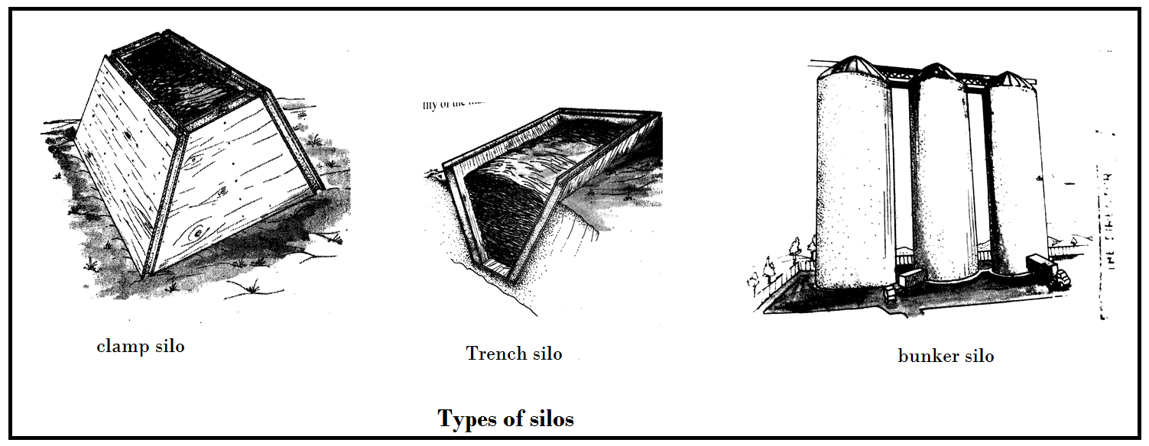

**Qualities of the good silage**

* Should be from high quality forage cut at the proper stage of growth
* Should have a of 4.2 or below
* Should have 5 to 9% of lactic acid
* Should be free of moulds and bad odour such as that of ammonia and butyric acids
* Should be green to yellow in colour but not brown or black
* Should have a fine texture but no sliminess

**Factors affecting quality of silage**

* **Age of the crop when cut for ensiling:** flowering stage is the best when crops plants have a lot of nutrients
* **Pasture species used:** for instance grass, legume or a mixture of legume and grass .legumes have higher crude protein hence higher in nutritive value than the pasture grasses.
* **Moisture content of the forage crop:** high moisture content lowers the quality of silage to sour. Low moisture contents makes the material pack insufficiently in the silo.
* **Extent pf compaction**: this affects the temperature in the silo which is crucial for the fermentation.
* **Filling duration:** faster filling of the silo is the best, as it minimizes loss of nutrients by volatilization.
* Leaf: stem ration of the silage material used: the higher the ratio, the better the quality as this affects the palatability of the feed.
* **Methods of storage used.** Should ensure that all material is well covered to prevent entry of water which may cause moulds formation.

**Advantages of silage making**

* Has high feeding value as it is succulent and is eaten without any waste
* It makes use of wide variety of forages, including those that cannot be made into hay e.g. Napier grass, maize, sorghum and stylo
* It is more palatable than hay and has a better smell
* Less vitamin A is lost then in sun-cured hay
* It is free from weeds, since weed are killed by heat in the silo
* Once ensiled, there are no storage problems and therefore kept for longer.

**Disadvantages**

* It is labour intensive and expensive
* It is bulky to store and handle
* It requires high level of skills
* It must be fed immediately after removal from the silo otherwise it spoils.
* Their moisture content is high, which reduces the amount of dry matter available to livestock

1. **Foggage**

* This ungrazed forage left in the field for feeding during dry periods.
* It is the most common method used by farmers in Malawi. Part of pasture land is not grazed until end of the rainy season.
* It is can only meet the maintenance ration requirement of animals and the supplementary feed should be provided.

**Advantages of foggage**

* It is cheap method of preserving feed.
* Animals get a heathier diet in its natural form
* No transport or handling costs are incurred

**Disadvantages of foggage**

* The degree of nutrients loss of nutrients loss is high especially when the forage is fed on
* There are losses through trampling
* Herbage quality is low due to over growth foliage
* It can only meet the maintenance ration requirement of animals and supplementary feed should be provided

**Factors that affect the quality of pasture**

* **Leafiness of pasture:** the higher the leafiness the higher the quality of pasture
* **Age at cutting of pasture**: at flowering stage, pastures provide the highest nutritive value
* **Moisture content:** higher moisture content lowers the quality of silage to sour
* **Presence of foreign materials:** these are unpalatable and some are poisonous
* **Method of storage;** wet or leaking storage facilities lower the nutritive value of the hay
* **Weather condition:** it must not rain during drying process, otherwise leaching of soluble nutrients are likely to occur
* **Pasture species used:** legume pastures are rich in crude protein than grass pasture.

# UNIT 14: BREED OF CATTLE

* **Beef** is the meat obtained from cattle is consumed by many people in the worlds. Malawi is not self-sufficient in production of animal’s proteins. There is a huge demand for animal’s protein both in rural and urban.
* All breeds of cattle can produce both meat and milk. However some can produce more of the one than the other.

**Breeds of cattle for dairy and beef production**

* **Dairy breeds:** those which produce a lot of milk
* **Beef breeds:** those that produce a lot of meat

**Table below shows breeds of cattle for beef production**

|  |  |  |
| --- | --- | --- |
| **Breed** | **colour** | **Origin** |
| Malawi zebu | Black, brown or white mixed | Indigenous |
| Hereford | Deep red with white face and legs | United kingdom |
| Simmental | Light red with white patches of and white head | Switzerland |
| Brahman | White or grayish | India |
| Charolais | White | France |
| Boran | Red, white, white-grey or brown | Kenya |
| Afrikander | Black | South Africa |

**Table below some cattle breeds for dairy**

|  |  |  |  |
| --- | --- | --- | --- |
| **Breed** | **origin** | **colour** | **Milk yield(kg)** |
| Friesian | Holland | Black and white | 5,000 |
| Guernsey | England | Fawn | 4,300 |
| Jersey | England | Brownish | 3,500 |
| Aryshire | Scotland | Red and | 4000 |

**Characteristics of cattle breeds for dairy**

* The legs are short and strong
* Very large udder with teats which are evenly spaced and well suspended but tightly attached to the body.
* Thin body which carries a little fresh and its pin bones visible.
* Wedge or triangular shaped-when viewed from sides
* Wide and well set hind quarters.
* Large stomach which enables animals to feeds heavily.
* Docile and mild temperament foe easy handling during milking.

**Characteristics of beef breeds**

* The legs are short to support heavy weight of an animal
* Beef are rectangular or square shaped referred to as blocky
* The body is compact and deep
* The animals grow fast and mature quickly
* They have heavy bodies with a lot of flesh.
* They are good foragers and so are able to feed on poor pasture
* High ability to convert pastures to high quality beef
* Tolerant to high ambient temperature
* More resistant to diseases as compared to dairy breeds
* Breeds regularly
* Deep chest and girth

**Management practices of for beef and dairy production**

* Management involves four main aspects
* Housing
* feeding
* Breeding
* Disease and parasites control
* In Malawi two management systems are used in beef cattle.
* Extensive
* Intensive systems

1. **Extensive systems**

* Under this system beef cattle are grazed on communal grazing fields. Animals are attended by the herd boys or girls to grazing areas to the dambos areas where there is good, fresh grass.
* Another form of extensive is ranching where beef cattle graze freely in the large farms. examples include; Dzalanyama ranch in Lilongwe, kuti in salima and some beef cattle ranches in chikwawa and nsanje

**Advantages**

* It is cheap to keep animals on communal land

**Disadvantages**

* It is difficult to control diseases and parasites
* Too many cattle may be kept in small areas, this lead to land degradation and overgrazing. Where human population is small and plenty of grazing land, is suitable.
* Animals take time to reach slaughter weight since animals walk from place to place looking for grass and water. Energy is lost in the process hence productivity is therefore very low.

1. **Intensive system/cut and carry or zero grazing**

* Under this system are kept in feedlots or grazed in paddocks when grazing is practiced.
* This system allows grass to grow and check of parasites and disease causing organisms due to rotational grazing.
* Animals here are intensively fed on concentrates, crops residue, agricultural by-products, grass (Napier or elephants grass) and minerals supplements

**Advantage**

* Since animal movement is restricted, they fatten more quickly
* Disease and parasite control is easier

**Disadvantages**

* System is more expensive
* Labour intensive

**Managing dairy cows**

* Dairy cows require a high of management to produce a high quantity and milk quality milk yield.

**Factors that affect milk yield**

1. **The breeds itself** some breeds produces more milk than the others e.g Frisian
2. **Milking techniques:**  milking is done by hand or through the use of machines should be completed within eight minutes to ten minutes and this coincides with the milk let-down period.

* Avoid “**avoid milking**” and “**under milking**”
* Over milking causes damage to the teats and udder due to the pulling on the teats after all after all the milk is finished.
* Under milking leaves the milk in the udder and develops mastitis. Cow milk may dry up quickly if some milk is left behind each time it is milked.

1. **Age of the cow:** milk yield increases with each calving up to the fifth lactation.
2. **Health of the cows:** Dairy animals should be in good health for high milk production as diseases like mastitis and milk fever affects the quantity of milk produced.
3. **Character of the cow:** a dairy cow should have a quite temperament as highly irritable cows tend to give less milk. It also ensures the safety of the safety of the milking.
4. **Nutrition of the animal:**  dairy cows should be given maintenance and production ration to ensure adequate milk production.
5. **Season/time of the year.** It is important to plan mating so that calving takes place where plenty of fresh grass so as to increase milk production
6. **Treatment of the cow:** lactating cows have to be treated gently to avoid holding up the milk.
7. **Period of lactation:** milk production increase rapidly soon after calving and later on it decreases as the animals is mated and carries an embryo insides until it dries off after 305 days(usually after ten months**).**
8. **Milking frequency**: it is recommended that cows be milked twice a day. This is very important

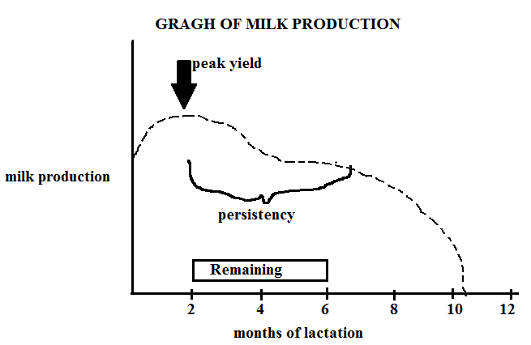

**A suitable house for cattle**

* Depends on the breed and age of the animal.

1. **For stall feeding beef cattle**

* A suitable house should be have fallowing require requirements
* It should be sited on a well-drained ground
* It should be well thatched
* There should be enough bedding on the floor
* It should be well ventilated and roomy. Allow a floor space of

1. **For dairy cows**

* Dairy cows need housing just like beef cattle. But an extra structure is required for milking. It is shown as a dairy shed or milking parlour.
* Two to four cows can be kept in a pen or Khola. A Khola for two cows should be a milking shed should be. The floor should be well made rough concrete to ease cleaning and should slope so that it drains well.

**The following should also be provided**

* A feed trough
* A roomy for storing feed, drugs and utensils
* A neck yoke for restraining the cows during milking
* Calf pen near the dairy shed

**House for beef**

* Beddings inform of maize stalks on floor so that they are comfortable. The beddings also absorb urine keeping the house dry all times.

**Housing for dairy**

* In the house include milking compartments
* Attached to the house is a store room where there is scale, freezer, washing basin, and a compartment for locking in utensils
* There is need to contrast an additional structures for calves so that they can be separated from their mothers.

**Identify suitable feeds for livestock**

* Animals are fed according whether they are

1. Calves
2. Heifer
3. Lactating mothers
4. Fattening animals
5. **Feeding calves**

* Immediately the calf is born it must be given the first milk called the colostrum.
* Farmers must ensure that the calf gets colostrum within first eight hours after birth and continues taking it for the next 4-5days.

**Importance of colostrum to newly born calf**

* It contains antibodies which are necessary for antibodies.
* It is more nutritious than the milk a cow produces after the colostrum. Colostrum is rich in proteins, vitamins, minerals and fat.
* Its digestibility is high and therefore suitable for calves whose digestive systems are not yet ready for solid feeds.
* Calves will feed on milk continuously for three weeks after birth. Thereafter, solids feeds may be introduced. Calves need a lot of production rations because they are growing. As results, supplement should be given to meet their growth requirements.

1. **Feeding heifer**

* **Heifer are mothers** for long time
* They are best raised in god pastures
* They need high quantities of production ration because they need it for growth and milk production. Proper feeding in necessary if the heifer is to conceive gain otherwise next pregnancy may delay because they may not come on heat.

1. **Feeding lactating cows**

* The amount of milk produced increases within the first two weeks. Thereafter, it starts to decline.

**Note the following of the lactating curve**

* As milk production increases for the first two weeks, and this should be sustained through adequate feeding and this is critical stage as animal may not produce adequate milk later if not well handled.
* Soon after two month, the cow is served with a bull after flushing the animal in order to induce heat period.
* The cow becomes pregnant while at the same time it is breast feeding calf and the farmer is also harvesting milk. Animals may lose weight at this stage if fed on poor pasture and it is necessary to prove maintenance ration and production ration at this time. Production ration will be for production of milk and maintenance ration for maintaining the body of the animal.

Note: each cow is given feed according to the amount of milk being produced.

**Feeding beef cattle**

* Feeding can be divided into the following :

1. **Feeding of breeding cows when they are dry and lactating**. Production ration will be given for the milk it produces for calf and the newly developing calf especially two months before calving.
2. **Feeding weaned steers and heifer.** The production of these animals is their growth i.e. the amount of bone, meat and fat they are producing each day.
3. **Feeding of fattening animals**: this can be on grass or in paddocks with concentrates**.** The aim of fattening animals for slaughter is to ensure that they should have a covering on their muscles while at the same time they do not get too fat

**Disease of the cattle**

* Cattle can be affected by the following diseases

|  |  |  |  |
| --- | --- | --- | --- |
| **Disease** | **cause** | **signs** | **Control** |
| 1. Foot and mouth disease | virus | * High fever * Animal develop blisters and therefore difficult to eat * Lameness * Continuous salivation * Drop in milk production | * Vaccinate all other animals * Slaughter and burry all infected animals * Has no treatment |
| 1. East cost fever(ECF) | Protozoa and transmitted by brown ticks and red | * High temperature * Loss of appetite(anorexia) * Excessive salvation * Diarrhoea * Anemia due to tick bites * Opacity (dulliness) | * Quarantine the animals in case of cut breath * Dipping animals to control ticks * Has no treatment |
| 1. Gall sickness(ananplasmosis) | Bacteria and spread by blue ticks | * High temperature * Loss of appetite * Pale mucus membrane * Staring coat * Death in severe cases * Pregnant cows may abort. * Urine may be brown * Milk production falls * Pulmonary edema | * Dipping cattle in tetracycline |
| 1. tuberculosis | Bacteria and spread through contact with other infected animals | * body temperature fluctuates * the animal loses weight * persistent coughing * increase in depth of rate of respiration * thick white vagina discharge * animal may become sterile * dullness * have snoring respiration or squeak or whistle | * slaughter infected animals * vaccine animals with BCG vaccination * treat animals with tuberculin |
| 1. cattle plague(rinder pest) | virus | * high fever * red urine * excessive salivation * diarrhea * blood stained feaces | * vaccinate animals every six month * quarantine all affected animals * slaughter affected animals |
| 1. brucellosis | Bacteria and spread through contact | * profuse sweating * joints and muscle pain * abortion in pregnant cows * swollen testicles in bulls * inflammation in genital organs in a cow | * slaughter infected animals * vaccinate remaining stocks |
| 1. anthrax | Bacteria and spread through ingestion or inhalation of bacteria | * animals suddenly drop down to dead * enlarged spleen after doing post-mortem * blood discharge mostly from anus and nostrils | * destruction and burying all dead animals * vaccinate remaining animals |
| 1. mastitis | Bacteria and spread through teat canal | * high fever * blood/pus stained milk * swollen udder and teats | * treat with antibodies e.g penicillin and tetracycline * practicing hygiene like washing hands with water during milking |
| 1. milk fever | Loss of calcium in blood | * general weakness * loss of appetite * heart failure | * provide calcium rich feed to animals |

**Ways of controlling disease in cattle**

1. **Vaccination:** this means introduction of disease causing organisms which are less pathogenic with aim of inducing the body to produce antibodies to fight against them.

**Types of immunity**

1. **Natural immunity**: this is the immunity acquired by an animal that was infected by diseases and has recovered. Antibodies remain in its body waiting for the same pathogens.
2. **Artificial immunity**: a acquire through vaccination
3. **Natural passive immunity**: acquire by calf as it take its first milk called Colostrums from its mother this immunity is short lived and therefore need alternative immunity
4. **Quarantine:** this is a method of excluding an enzootic area whenever there is an outbreak of disease so that the disease remains in that are without crossing to new areas where4 it has never existed before.
5. **Isolation:** this is method of keeping infected animals away from the rest until the infection has been treated. The aim is to prevent the spread of diseases to the healthy ones through contamination of feed, water and the floor.
6. **Slaughter:**  there are some diseases that have no treatment or treatment is not cost effective.
7. **Control of vectors:** tick-borne diseases like east coast fever, red water are best controlled by dealing with their transmitting agents like ticks and tsetse flies.
8. **Hygiene:** this helps to keep pathogens in economic threshold; where necessary the house should be cleaned and disinfected with chemicals.
9. **Diagnosis:** when disease is diagnosed early, it is easy to treat it because the disease has not yet developed a strong foothold in the infected.

**Parasites of cattle**

* There are two groups

1. external parasites e.g. ticks, tsetse flies
2. internal parasites e.g. tapeworms, roundworms(nematodes) and liver fluke
3. **Ticks**

* suck blood from cattle
* transmit numerous kind of viruses, bacteria and protozoa between domestic animals
* Are mostly found in tropical and subtropical countries where it is warm and enable them to flourish.

**Life cycles of ticks and liver flukes**

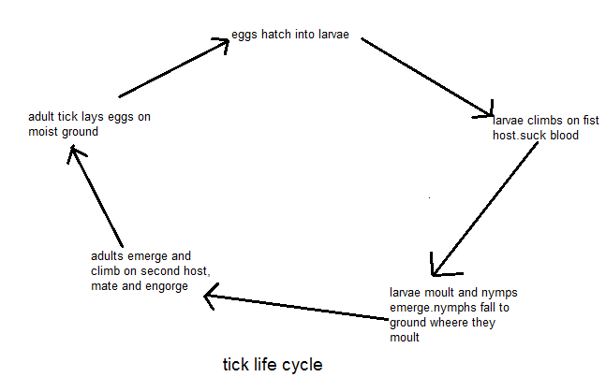

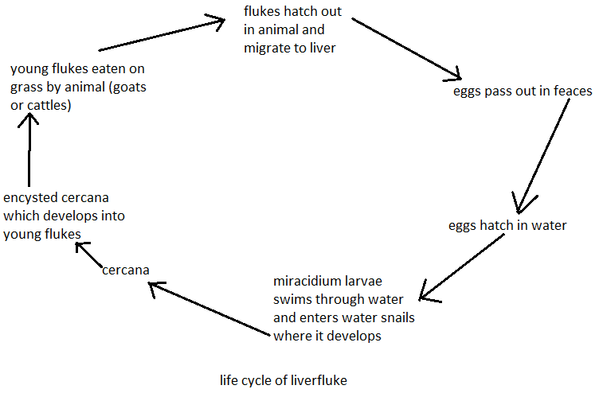

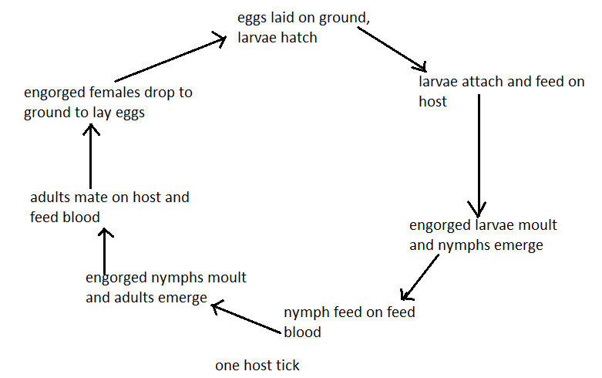

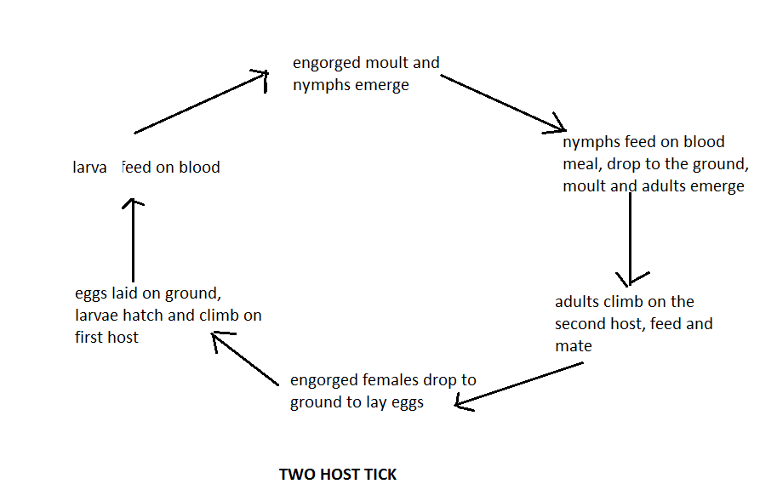

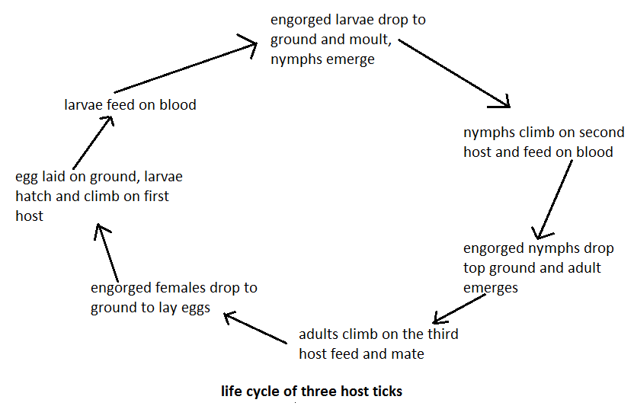

**Signs of tick attack on cattle**

* wound on skin due to heavy bites
* emaciation because ticks suck valuable nutrients required for body building and maintenance
* Itching causing restlessness and this occurs at the point of infection.
* On herd basis the accumulated effect of this biting stress can cause loss of appetite and loss of blood.
* Result in food intake and anemia
* Cause lower growth rate or milk reduction compared to host without tick infestation

1. **Tsetse flies**

* Are large biting flies that inhabit much of mid-continental Africa between the flies.
* They live by feeding on vertebrates animals
* They transmit diseases called sleeping sickness and animal Trypanosomiasis also called nagana.

**Signs of infection**

* **Body irritation**: the animal feels itchy as tsetse fly pieces its proboscis into the animal’s body.
* Animal feels weak due to loss of blood to tsetse fly
* Loss of production

**Internal parasites**

|  |  |  |
| --- | --- | --- |
| **Parasites** | **Damage/signs of attack** | **Control method** |
| 1. **Round worms** | * Attack intestines * Absorbs digested food from animals * Animals have enlarged stomach (pot belly) especially calves. * Continuous diarrhea | * Deworming by drenching animals with phenothiazine * Practice rotational grazing * Low stocking rates * Deep ploughing in order to bury the eggs |
| 1. **Tape worms** | * Attack small intestine and suck blood * The meat look measly because larva enters the bloodstream and settle in the muscle * It also affects people who eat the infected meat | * Practice rotational grazing * Drenching animals with appropriate drugs * Deep ploughing in order to bury the eggs |
| 1. **liver fluke** | * it attacks the liver * animal get it through grazing in wet dambos * it causes general body weakness * it causes internal breeding in animals | * destroy the snails which are intermediate hosts with copper sulphate * avoid grazing animals in wet dambos * practice rotational grazing |

**ZOONOTIC DISEASE:** diseases which affect both animals and humans

# 

# UNIT 15: REPRODUCTIVE SYSTEMS OF POULTRY AND CATTLE

* Reproduction is the system whereby life is perpetuated by raising a young one by fertilization of an egg from the female by sperm produced by the male

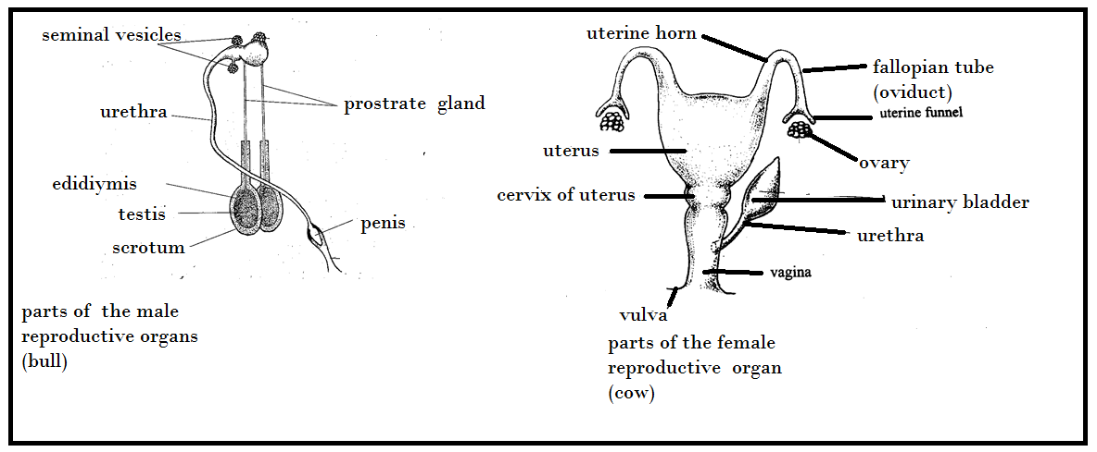

**Functions of different parts of the reproductive systems of cattle and poultry**

1. **Reproductive systems of a bull**
2. **Scrotum:** is a sack which holds the testicles outside the body cavity by providing an ideal temperature for sperms development.
3. **Testicles**: they are two oval-shaped and glandular organs enclosed in scrotum. They produce spermatozoa. They also secrete male hormones
4. **Epididymis:** is large coiled tube that surrounds each of the testicles. Provide temporal storage of sperms.
5. **Vas deferens:** also known as sperm duct. They carry sperms from the testicles to the urethra where the reproductive systems join the urinary systems.
6. **Urethra:** it is a tube that leads from the bladder through the penis. It is a passage from both urine and semen.
7. **Penis:** it is the organ of copulation during mating. It makes possible the introduction of sperms cells into vagina. It has spongy tissue that gets filled with blood as the bull mates with the cow, facilitating entry into the vagina of the cow.
8. **Glands:** found at the neck of the urinary bladder that is where the reproductive system meets the urinary bladder.

**There are three glands:**

1. **Prostrate:** produce saline glucose rich fluid that activates sperms
2. **Cowper’s gland:** produce mucoid fluid that precedes sperms and helps to neutralize the acidity of the urine in the urethra which is harmful to the sperms.
3. **Seminal vesicles**: produce the seminal fluids in which sperms are carried
4. **Sigmoid flexure:** enables the penis to get out of the sheath as it penetrates into female’s reproductive system when it stretches and retract after copulation.
5. **Retractor muscle:** they help in pulling the exposed penis back into the sheath.
6. **Prepuce:** it is also known as the sheath. It protects the glands from external injury. The glands penis is free end of the penis containing sensory nerves
7. **Reproductive organ of a cow**
8. **Ovaries:** these are to oval-shaped organs which produce female gametes(oval or ova)

* Ovulation: the process of releasing eggs from ovaries to the oviduct

Ovaries also secrete female sex hormones which control sexual cycle.

**Ovulation processes in cow**

* “*Graafian follicles in the ovary produce oestrogen which induce heat period.*
* *This follicle then matures and ruptures(break) when the egg is released into the oviduct (fallopian tube).*
* *The hole is filled by other cells to form a body called corpus luteum (yellow body).*
* *This body grows two weeks after ovulation has taken place.*
* *The corpus luteum produces progesterone, a hormone that helps the process of ovum implantation in the uterus and development of mammary glands.*
* *If the egg is fertilized, corpus luteum is retained for the whole period of pregnancy.*
* *If fertilization does not take place, the corpus luteum degenerates”.*

1. **Funnel:** receives the ovum during ovulation directing into the fallopian tube.
2. **Fallopian tube:** also called oviduct. They assist in the movement of eggs to the uterus. It is where fertilization takes place.
3. **Uterus:** where fertilized egg is implanted in the walls of the uterus and where the embryo grows and develop into young animal.
4. **Cervix:** the opening between vagina and uterus. It is closed during gestation period while it is wide open when the animal is on heat. The calf during parturition the calf passes through it into the vagina.
5. **Vagina:** it is the female copulatory organ where sperm are deposited. It also serves as the passage of urine.

**Puberty stage of cattle**

* **Puberty:** is the stage of sexual maturity or reproductive competence in animals.
* Male produce sperms and female begin to develop eggs
* Period is reached before the mature body is attained.

**Age puberty for some animals**

|  |  |  |
| --- | --- | --- |
| Type of the animal | male | Female |
| Cattle | 11 months | 11 months |
| Sheep | 7 months | 7 months |
| Goats | 7 months | 7 months |
| rabbits | 3-4 months | 7 months |

**Factors affecting the onset puberty**

1. **Genetics:** different breeds reach puberty at different ages. For examples jersey reaches puberty earlier than Friesian.
2. **Animal type**; dairy cattle reach puberty earlier than beef
3. Cross breeds reach puberty earlier than pure breeds due to heterosis (hybrid vigour)
4. **Body weight** is a more important factor influencing puberty than the age. For example, dairy cattle will reach puberty when they have attained 30-40% of the adults’ weight, beef cattle at 45-55% of the adults.
5. **Nutrition;** poorly fed animals will delay puberty while flush feeding may stimulate puberty
6. **Warmer temperatures** lead to early onset of puberty while extremes of temperatures extend the onset
7. **Exposure to opposite sex;** animals’ exposed to opposite sex reach puberty earlier than those raised in the same sex groupings. This is due to pheromones effects.

**Oestrus cycle for cows**

* Is the period between two successive heat periods when the animals is not pregnant.
* During this period the female shows the desire to mate

**Oestrous cycle and ovulation periods**

|  |  |  |  |
| --- | --- | --- | --- |
| **Type of animal** | Length of oestrous cycle(14days) | Duration of oestrous (hours) | Ovulation period in hours |
| Cow | 19-23 | 10-26 | 4-6 hours after onset of oestrous |

**Phases in oestrous cycle**

1. **Proestrus Phase (day 17-20)**

* Lasts up to three days and the reproductive trod is prepared muscles of the ovary grow and vagina walls thicken due to influence of oestrogen

1. **Oestrus(day one of new oestrous)**

* This is the stage when the animal has a strong sexual desire and shows the signs of heat
* The follicles continue to grow to maturity.

**The following are the signs**

* Reddening of the vulva
* Restlessness
* Standing to be mounted
* Drop in milk production

1. **Metoestrus (2-4 days)**

* The period when corpus luteum is formed and the body secretes progesterone which suppresses the growth of the follicles so that no more eggs are released.

1. **Dioestrous (day 5-17)**

* At this stage the corpus luteum is retained if fertilization has taken place and the animal is pregnant.
* They are high levels of progesterone in blood circulation

**Signs of oestrus (heat) in livestock**

**Early signs**

* Increased nervousness or restlessness result in greater physical activity in the cow
* Increased in urination
* Animal tends to wag tail, or twitches and elevate her tail
* Animal mount other cows but will not be mounted herself
* Licking, nudging and sniffing of the genital area of the other cows
* Lips of the vulva become swollen and congested with blood

**Signs during standing heat**

* A cow stands to be mounted by another cow.
* A thin clear, watery mucus discharge from the vulva is a signal that a cow is in oestrus
* Food intake may be reduced during estrus
* Drop in milk production

**Late signs of heat period**

* cow no longer stand to be ridden, but may mount another cow in standing heats
* hair on the tail head is rough or rubbed off due to mounting
* hair on the tail or directly below the vulva may be matted because of dried mucus

**Importance of knowledge of heat period**

* It helps the farmer to mate (serve) at the right time so that fertilization can take place.

**Timing chart for mating cattle**

|  |  |  |
| --- | --- | --- |
| **Standing heat** | **Out of heat** | **Egg is fertile** |
| 16-18 hours   * Cow stand to be ridden and is restless | 10-12 hours   * Cow quietens down and becomes normal * Insert cow quite |  |
| Hours 1 23456789101112131415161718 | 123456789101112 | 123456 hours |
| **Too early** | **Best time** | **Too late** |

**Chat for mating cattle**

|  |  |
| --- | --- |
| **Standing heat first observed** | **When to breed** |
| In the morning | The next morning |
| In the afternoon | Late afternoon of the same day |

**Gestation period for cow**

* **Gestation**: *it is the period from conception to the birth of a young animals*

**Gestation period for selected animals**

|  |  |
| --- | --- |
| **Types of the animal** | **Length of the gestation** |
| Cow | 275-285 |
| Ewe | 150 |
| Sow | 115 |
| Nanny | 143-153 |

**Process of reproduction in cattle**

* Reproduction goes through the following n process

1. **mating**

* Is either by natural or artificial insemination? In artificial insemination(AI), semen is collected from a superior male is introduced in the female reproductive tract of a female by use of a syringe or pistolette

1. **Fertilization**

* This takes place when the male fuses with the female gametes
* The fertilized egg forms a zygote which travels down to the oviduct and attaches itself to the uterus wall (i**mplantation**).
* This takes 15 days in cow and 30 days in ewe
* Rapid cell division takes place for a zygote to form an embryo then a foetus.
* The unfertilized sperms take 20 to 30 hours in the female track before dying

1. **Embryo development**

* During the early stages of embryo development, the villi form the sites of material exchange between the embryo and maternal blood vessels in the uterine wall.
* Amniotic membrane surrounds the embryo and is filled by amniotic fluid
* Amniotic fluids: suspends the foetus providing it with support and also acts as shock absorber to protect foetus against mechanical injury.
* Embryo is attached to the foetus by umbilical cord. The embryo becomes foetus after 3 month of pregnancy.

1. **Foetus Development**

* Foetus gets it requirement for growth from placental from it mother through diffusion process and this is aided by villi in placental.
* Once fertilization has taken place, the fertilized ovum goes through the following staged of development.

1. **Stage of the ovum**

* Cells increase in numbers and soon after fertilization there is only one cell. This divided into 4, 8 and so forth until they become 32 undifferentiated cells. As they divide they also moving toward the uterus for implantation.

1. **Stage of the embryo**

* Cells then start to differentiate forming different body parts starting either the gut. The process is very slow and by end all parts are completely formed except animal pigments.

1. **Stage of the foetus**

* The last stage of pregnancy and body parts begin to increase in size rapidly, by end of end of 9 months, the4 foetus is ready for parturition.

1. **Parturition**

* This is the process of giving birth

**Signs that the animal is about to give birth**

* Becomes restless and looks for a quiet place
* The udder becomes large
* There is mucus discharge from the vagina
* The pelvic ligaments relax and becomes soft
* The cow usually takes about 5 hours to clave after onset of labor, this is normal parturition.
* **Dystocia or dystokia**: is the term used when a cow is having difficulties or complications in giving birth.

**Signs of complications during the process of parturition**

* A long delay in appearance of calf once the water bag breaks
* If the cow is taking over three hours after some parts of the calf appear
* If the calf is coming out abnormally, they is rear parts trying to come out first. This is breech presentation
* If a cow is in distress such that there is no sign of water bag after many hours of straining
* Only one limb appearing after the water bag has burst.
* Discharge of smelly fluids indicating death of calf
* **The after birth** (placenta, foetal membrane and umbilical cord are ejected out).the cow normally eat and lick the calf to remove mucous, especially from the nose mouth, so that the calf is able to breathe properly.
* Allow the calf the suck and get Colostrum and then move the calf to a warm pen during chilly weather.

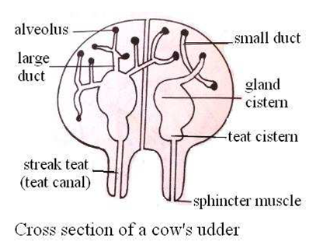

**The process of milk let down**

* When dairy cow hears the sound of milking chums or cry of calf, the pituitary gland secrete a hormone oxytocin hormone which is released into the bloodstream. As the oxytocin reaches the udder region, it causes the baskets cells to contract, hence squeezing milk from the lumen of the alveoli secrete cells into the smaller ducts. From the smaller ducts, milk flows into larger ducts and is stored in the gland cistern and then into teat cistern. Upon milking the cow, milk is then squeezed through the treat canal and is let out through the sphincter muscle.

**Hormones that influence reproduction process**

|  |  |  |
| --- | --- | --- |
| **Name of hormone** | **Place where it is produced** | **Functions** |
| Follicle stimulating hormone(FSH) | Pituitary gland(on the animal’s brain) | * It stimulates the growth of follicles * It stimulates the development of the ovaries |
| Oestrogen | Follicle and developing ovary | * Brings about oestrus * Influences development of mammary glands * Influences the pituitary gland to produce luteinizing hormone |
| Luteinizing hormone(LH) | Pituitary | * Stimulates rapture of follicle to release eggs * Initiates production of corpus leteum essential for the maintenance of pregnancy |
| Progesterone | Corpus luteum and placenta of pregnant animal | * It influences development of ovary * Stimulates follicle development * Influences development of mammary glands * Influences the development of uterine walls * Inhibits ova production if the animal is pregnant. |

**Reproductive system in poultry**

**Reproductive organs of a cock**

* The male reproductive systems consist of tests, vas deferens, papillae and cloaca.
* Both testes are located in the interior end of the kidneys in the dorsal body wall.
* The size of the testes varies with reproduction cycle; they are enlarged during breeding time.

**Functions of parts of reproductive systems of a cock**

* **Testis:** produces the males gametes
* **Vas deferens:** passage of sperms from testis
* **Papillae:** acts as mating organ
* **Cloaca:** presses the hen during mating

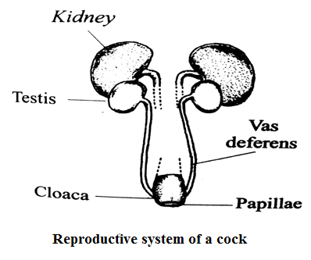

**Reproductive organs of hens**

* Has only left ovary functional and the right ovary is not fully developed (it atrophies).
* It consists of one ovary and one elongated oviduct. The ovary is firmly attached to the dorsal walls.

**Functions of reproductive parts of a hen**

1. **Ovary :** it produces ova
2. **Oviduct:** a long tube on average about 65cm long and consists of the following parts.
3. Infundibulum
4. Magnum
5. Isthmus
6. Shell gland (uterus)
7. Vagina
8. Cloaca

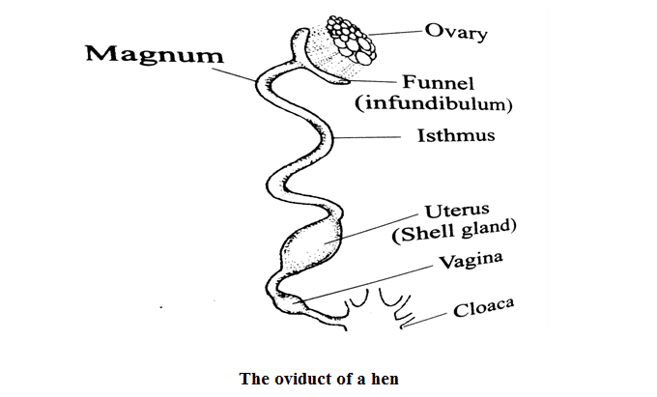

1. **Infundibulum**: it is also called the funnel. It has thin walled and has cilia which aids in egg movement. It stores sperms after mating with a cock. The yolk is fertilized here. It from chalaza, which is a membrane of twisted strings that’s suspends the egg yolk in position.
2. **Magnum:** a region which cause rotation of eggs yolk as albumen is added.
3. **Isthmus:** Thin albumen is added to egg. Mineral salts, water and vitamins are also added. Thereafter, the two membrane are added to enclose the egg contents.
4. **Uterus:** also know and as shell gland. It is thick wall and adds water and mineral salts by process of osmosis to dense increasing its volume. Egg shell is added through deposition of calcium. Shell protects the egg contents and allows gaseous exchange.
5. **Vagina:** it is where fully form egg is passes through this part. the process of laying called oviposition.
6. **Cloaca:** serves as copulatory organ where the vent of the hen opens to the cloaca of the cock and sperms are deposited into it. Hen does lay eggs without mating with a cock.

* The process of egg formation in a hen take about **24-36** hours before the egg is laid. Thus the hen is bale to lay only one egg a day.

**UNIT 16 LIVESTOCK IMPROVEMENT**

* **Livestock improvement** is an act of improving the hereditary material in animals I order to increase animal’s yield.
* The potential for animals to produce high quality milk, meat, wool and eggs is a function of **genetic make-up** inherited from their parents’ couple with housing, feeding and control of pests and diseases.
* A male and female each provide the cell (gametes) which carry the genes that are passed on to new off-spring.
* The sex cell through meiosis goes through reduction division so that each cell contains equal number of chromosomes (**haploids).**
* After fertilization, chromosomes from the two cells combine to form the correct number of chromosomes (**diploid).**

**Aims of livestock improvement**

* The aims include developing breeds which can

1. Adapt to prevailing environmental conditions so that they are able to survive and produce highly
2. Produce high products such as milk, meat, wool, eggs
3. Produce high quality products in terms of egg size and color of egg yolk, butter fat content in milk, quality of wool
4. Resists diseases and pest attack
5. Have a high rate of growth so that they can reach a slaughter or breeding stage early.
6. Resists disease and pest attack
7. Have a high rate of growth so that they can reach slaughter or breeding stage early.

**Methods of livestock improvement**

* There are three main methods of livestock improvement
* Introduction
* Breeding
* Selection

1. **Introduction**

* This implies bringing exotic animal breeds which are basically pure bred animals with superior qualities from another countries.
* For example Malawi has received several of these breeds from other countries through introduction. For example milk producing breeds such as Friesian, Jersey now exist in this country introduction.
* The introduced exotic breed is brought into a totally new environment which may affect its survival and performance.
* Farmers must therefore manage them properly in terms of disease and pest control, feeding and housing.

1. **Selection**

* Animals are chosen on the basis of their superiority and develop a breed which is better performing than the previous ones. Those that are inferior are sold out.

**Methods of selection**

1. **Artificial selection**

* Animals are selected by a breeder based on their external characteristics(phenotypic) such as body size, egg size or genotypes

1. **Individual or mass selection ( sib selection)**

* This involves the selection of individuals based on their performance. The out ward appearance of the animals, i.e. phenotypic characteristics, are used to choose the best animals. Such characteristics are observable or measureable.

1. **Selection by contemporary comparison**

* This is the comparison of animals based on their individual performance. The best individual is selected from the same age-group that have been similarly treated. The animals should be within the same environment.

1. **Progeny testing:** selection of male animals on the performance of their offspring. This helps males to transmit the production potential to female offspring.
2. **Natural selection**

* The breeder has no part in this type of selection.
* Animals that suit an environment survive while those that do not die off.

1. **Breeding**

* This is the process of mating selected animals for the purpose of producing animals with desired traits.
* Quality of animals depends on the genetic characteristics inherited from the parent stock and the prevailing condition under which animals are raised.

**Characteristics of livestock to be selected for breeding**

1. **Fast growth rate**: this is a merit because farmers do wait for too long a time before they start receiving income from sale of the animal.
2. **Resistance to diseases and pests**. This reduce production costs
3. **High survival rate**(low infant mortality) to increase rate of animal multiplication
4. **High survival mothering ability:** mothers must be able to provide their young ones with milk, eggs and protection from any impending danger.
5. **High fertility rate**. in beef production, mothers should be able to conceive every year in order to increase number of beef cattle
6. **High meat quantity and quality.** This is due to the body size the animal reaches at its slaughter stage and attributes such as fat content,
7. **Temperament:** a breed which is docile is easy to milk, use as source of power and their meat is good quality.

**Livestock breeding systems**

* There are three breeding systems which breeder use in order to improve livestock productivity.

1. **Cross breeding**

* Is the mating of animals of different breed composition or types?
* Offer advantage which is heterosis(improving vigour)

1. **Inbreeding**

* Mating of closely related animals. This include sire to daughter, son to dam and brother to sister

**Advantage**

* It essential in development animal with uniformly “stamp” on their progeny
* It brings about uniformity in the animals
* To uncover(reveal) the genes that produce abnormalities or death
* Fixes desirable genes if it is done for over 10 years pure breeds

**Disadvantage**

* It reduces overall performance of animals in terms of: vigour, disease resistance, reproductive efficiency and survivability.
* It also increases the frequency of abnormalities**.**

1. **Out breeding**

* The mating of animals of the same breeds but which have no close relationship than at least 4 to 6 generations.
* Animals since they are not closely related, they pass on different but superior genes into the progeny, making them better than their parents. It brings heterosis than inbreeding.

**Selection of dairy cattle**

**The following characteristics should be considered**

1. **Productivity**

* Select cow based on their milk production per lactation, butter fats content and length and lactation period.

1. **Body conformation**

* Typical dairy cow is slightly wedge-shaped (triangular shaped) when viewed from side.

1. **Reproductive traits**

* Such traits include; mothering ability and calving interval. Good dairy animals should calve once a year.

1. **Adaptability to the environment**

* Choose breeds that are well adapted to a particular environment

1. **Health**

* Choose animals which have been less affected by prevalent environmental diseases. Animals suspected of hereditary disease should be left out.

1. **Physical defects**

* Choose animals which do not have any physical defects such lame, cryptorchid (undescended testes, and gummers ( no teeth)

1. **Dairy temperament**

* Docility is preferred since docile animals are easier to handle.

**Selection of beef cattle**

1. **Body conformation**

* The body should be block or rectangular or square in shape

1. **Maturity**

* Should have a rapid growth rate and reach slaughter weight early

1. **Productivity**

* Consider the carcass quality, that is , the juiciness of the beef
* Select animals that show good meat marbling, that is, uniform distribution of fat in the meat. However this can only be detected when an animal has been slaughtered
* Consider the kill out percentage of the animal
* **Average kill out percentage should be over 60%**

1. **Heath of animals**

* Selected animals resistant to prevalent disease particularly those with good health records

1. **Adaptability to the environment**

* Select animals which are tolerant to the prevailing environmental conditions.

**Artificial insemination (AI)**

* Is a tool for livestock improvement in which involves introduction of sperms into female reproductive system without the use of a bull.
* Semen is collected from outstanding bulls by use of an artificial vagina as it tries to mount a female. Semen is the diluents with using diluents which consists of egg yolk, milk and glucose. It is later stored in liquid nitrogen which is under very low temperature. The semen can be stored for very long periods of time and still remain viable.

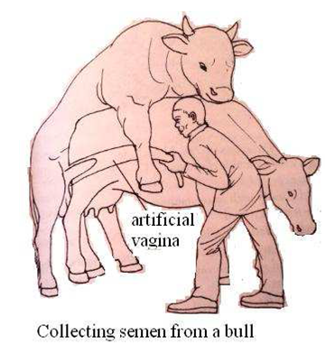

**Advantage of AI**

* Semen from one male can be used to serve many female up to 200 cows.
* Semen can be stored for many years and still use it long after the bull is dead. This ensures that its traits can continue to spread even after its death.
* It reduces the cost of buying and keeping a bull
* Traits of an outstanding bull can spread more widely than use of live bull because it only takes transportation of its semen to continue far and wide.
* It reduces spread of sexually transmitted disease
* Bulls which are too heavy to mount can have their semen still be used which would have difficult under natural conditions.
* Breeding is very easy to plan.

**Disadvantages of AI**

* The system required highly skilled personnel
* Due to some logical problems such as transport, it is difficult for the skilled officer to come and inseminate a cow in time when heat signs are selected.
* It is expensive to manage the AI program